
What can you expect to see in a maths lesson at St Edward’s?

The core aims of maths teaching at St Edward’s
When designing the curriculum for our children, we wanted to ensure that our decisions were informed by our overall vision for the school:
St Edward’s is a caring, Christian community with a love of learning where children achieve their potential, are confident in themselves and their abilities and are set on a positive path for life.

Explorers – We want our children to be curious. We aim for them to be on the lookout for patterns and trends, and to ask mathematical questions. We want them to be able to generate hypotheses and explore them with confidence. We want to equip them with skills to be explorers and to develop a life-long love of learning.


Resilience – We would like our children to see learning as a life-long path and to embrace challenge. We would like them to develop independence in their learning and have confidence to … We aim for them to have plenty of opportunities to share misconceptions and be able to explore and learn from them without fearing failure.

Creativity – We would like our children to make links within their maths learning and also to be able
to think ‘outside the box’ in their approach to solving problems.


Competence – We want to ensure our children are equipped with the language, secure mathematical understanding and confidence to be able to apply maths learning in a range of contexts. We want them to develop fluency and accuracy in readiness for high school and beyond. We aim for them to be articulate when explaining their reasoning and strategies.

Power Maths Lesson
Teachers are not expected to complete a full lesson per session. Staff are encouraged to respond to the needs of the children and avoid moving on too quickly. Lots of time is spent ensuring that all children have secured a concept before moving on. Where essential small steps are missing, time is spent revisiting relevant learning.
The vocabulary for each unit of work will have been discussed at the start of the unit and will be on display in the classroom so that children can use it appropriately. Children are expected to answer in full sentences as much as possible.
Children are seated in mixed-attainment pairs, and all children are expected to participate at every stage of the lesson.
If SEND children are unable to access learning, this will have been discussed with the SENCO and alternative provision may be provided.
In EYFS, children work through the stages of the Power Maths lesson much more slowly. The different sections of the lesson are delivered as individual lesson each day.
Discover
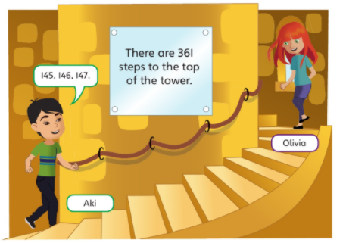
Children are asked to look at the picture on the screen and discuss with a partner everything they notice. Ideas are then shared as a class. They use the stem sentence ‘I notice that…’. Children respond to one another’s ideas, and this part of the lesson is clearly differentiated by outcome. All children feel confident to participate as all contributions are valid.
Vocabulary issues and misconceptions are clarified during this session.
There is little actual input from the teacher at this stage, prior to the children attempting the questions.
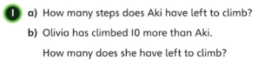
Children are given time to attempt the Discover questions with a partner. Across the whole school, they are often provided with relevant manipulatives so that they can explore and explain the concept. These manipulatives will usually mirror those used in the textbook in the Share section

(in this example, they would be given base ten)
During this session, the teacher may pause children to use the rich questions from the teacher guide to offer additional support.

Share

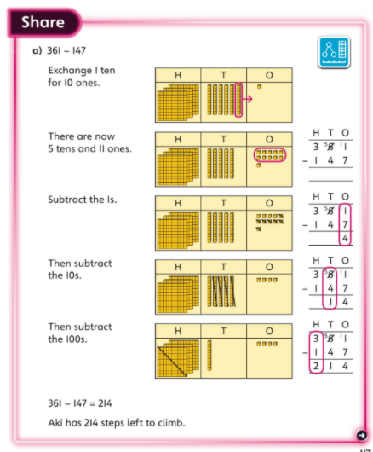
The teacher then goes through the Share section with children and they discuss any similarities or differences.

Think Together

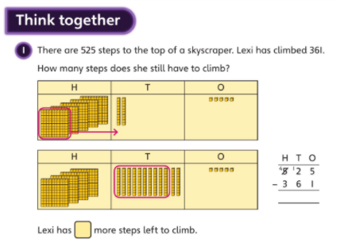
Unless the children are already confident with the concept, the Think Together section is done with an ‘I do, we do, you do’ approach.

The teacher models the first question. Often the manipulatives will have been removed at this stage, and there is more focus on visual representations and abstract calculations with reference back to the manipulatives to ensure that the connections are being made.
If children are still struggling to grasp the concept, the teacher may decide to extend the use of manipulatives.

The second question is done by the whole class together, and the third is done independently on whiteboards.

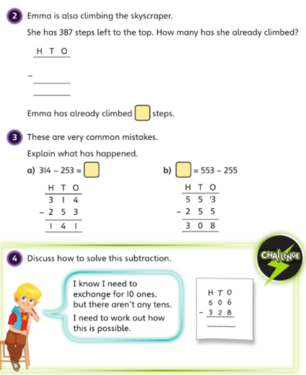

All children are expected to attempt the challenge with their talk partner. The whole class then discuss possible solutions.

Workbook

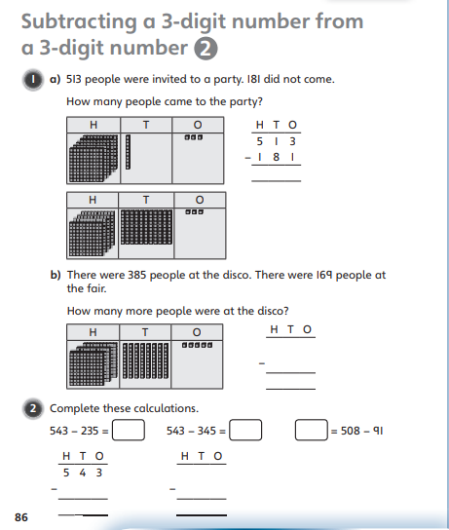
Completion of the workbooks looks very different across the key stages. In KS1, the children require lots of adult support with reading the questions, but are encouraged to attempt the questions with increasing independence.

In Lower KS2, some children may still require support with reading questions, so some class teachers may read questions from the front.

In Upper kS2, children are expected to answer the workbook questions independently, with peer or adult support given to those children who request it.

Greater Depth/ Early finishers
Teachers encourage children to challenge themselves throughout sessions by noticing patterns, generating hypotheses and testing them. E.g. ‘All multiples of 8 are also multiples of 4’.

Additional challenges available include those suggested in the Power Maths planning overview; NRich tasks; and Andrew Jeffrey’s Greater Depth challenges.

Children who have finished fairly quickly but aren’t necessarily ready for greater depth tasks might be provided with materials covering the concept using different representations – e.g. they may be given White Rose questions on the same topic.

