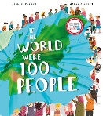
Special Dates  For Year Six | Week beginning 7th September – School Council Elections  8th September – Meet the teacher 9:00am  15th September – International Day of Democracy  15th September – Meet the teacher 3:20pm  15th and 23rd September – Participating in Eden Project live workshops to support learning about adaptations in different biomes  19th October – Upper Key Stage Two Parent Workshop  21st September – 6 Oak Reading Café – 2.45pm  21st September – International Day of Peace (covered in school)  Friday 25th September – Visit from local MP Elsie Blundell for question time and discussion about democratic systems  5th October – 6 Willow Reading Café – 2.45pm  12th- 18th October – Road Safety Week  Highlighted dates indicate parent involvement

Books we’re reading | 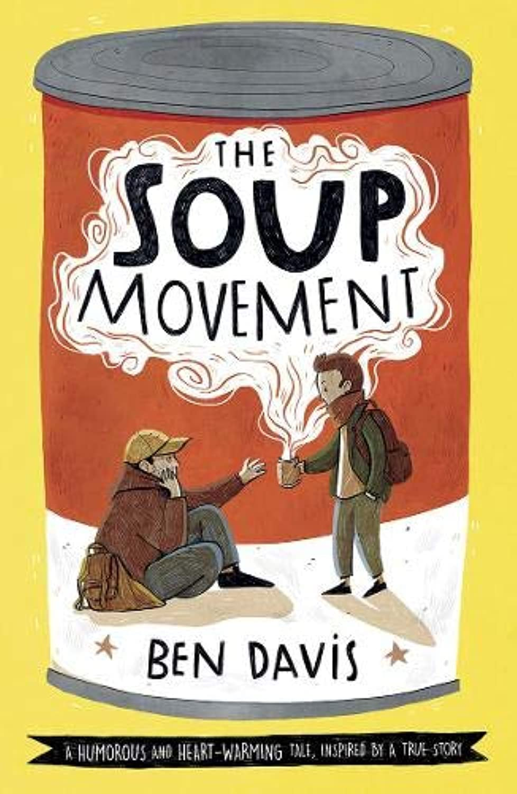
Music we’re listening to | 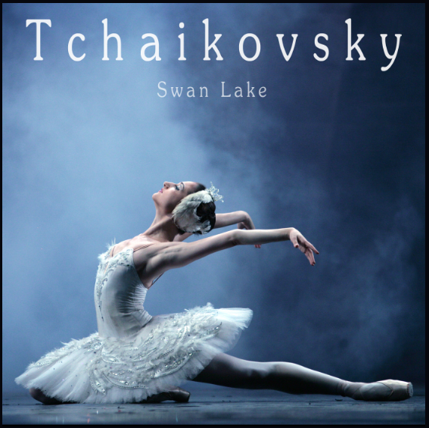
Whole school spoken Grammar Focus | I went park. ❌  I went to the park. ✔️

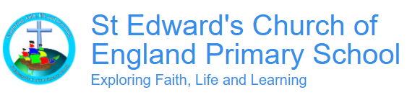

Autumn 1 2026
Term Begins: Thurs 3rd September
Term ends: Thursday 22nd October

 | Unit of work |  | Discussion points/ how to help at home | Vocabulary
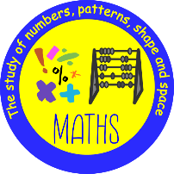 |  | 4 operations  Place value | Can they label numbers with place value headings?  How do you set out column addition and subtraction? What does short and long division look like? Can you set out short and long multiplication?  DR ML- divide right, multiply left  KFC- keep, flip, change | Value  Column  Product
 |  | Times tables practice |       (Please contact class teachers if you need any login details) | Factor  Multiple
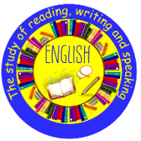 | Rose Blanche- diary and bravery award speech |  | What does this tell us about the character?  What connection can you make with other objects?  Is anything puzzling you?  Could there be a different explanation?  What is your impression and why? | Shrouded  Paraded  Triumphed  Rutted tracks  Cold retreated
  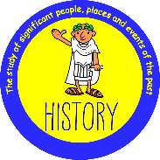 | What can the Census tell us about local areas? |  | 1. What is a census and why is it useful?  Your child should explain that a census is a survey of everyone living in the country. It helps us learn about people, places and how communities have changed over time.  2. What kinds of information can historians find in a census?  Look for answers such as names, ages, jobs (occupations), where people were born, relationships within families and information about homes.  3. Why do historians use more than one source to learn about the past?  Your child should recognise that historians compare evidence from sources such as census records, old maps and birth, marriage and death records to build a reliable picture of the past. | Census (an official survey that collects information about everyone living in a country)  Occupation (a person's job or profession)  Historical enquiry (finding out about the past by asking questions and using evidence from different sources)
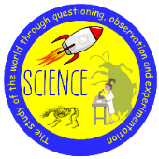 | Evolution and Inheritance |  | 1. Why don't offspring look exactly the same as their parents?  Your child should explain that offspring inherit characteristics from their parents, but there is variation, so individuals of the same species are never exactly alike.  2. What is an adaptation? Can you think of an example?  Look for an explanation that adaptations are features that help living things survive, such as a penguin's thick layer of fat or a flower's nectar attracting insects.  3. How do fossils help scientists learn about the past?  Your child should explain that fossils provide evidence of plants and animals that lived millions of years ago and show how species have changed over time. | Variation (the differences between individuals of the same species)  Adaptation (a characteristic that helps a living thing survive in its habitat)  Fossil (the remains or traces of a plant or animal that lived a long time ago)
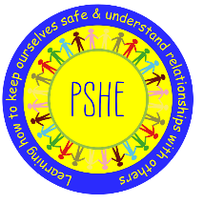 |  | Being Me in My World | 1. What is the difference between a want and a need?  Your child should explain that needs are things everyone requires to live safely and healthily, while wants are things we would like but can live without.  2. How can your choices affect other people?  Look for examples of how kind, respectful and responsible choices can have a positive impact on friends, family, school and even the wider world.  3. Why is it important for everyone to have a voice in school?  Your child should explain that listening to everyone's ideas helps people feel valued and allows the school community to make fair decisions together. | Democracy (a way of making decisions by listening to everyone's views and having a vote)  Responsibilities (things we should do to help ourselves and other people)  Empathy (understanding how someone else feels and showing kindness and care towards them)
 |  | Relate  Engage
 | Why do some people think God exists? |  | 1. Why do some people believe in God, while others do not?  Your child should explain that people have different beliefs and experiences. Some believe in God, some do not, and others are unsure.  2. How do people explore big questions about life and God?  Look for answers about using religious texts, evidence, reasoning and thinking carefully about different ideas and viewpoints.  3. Why is it important to respect different beliefs?  Your child should explain that people hold different religious and non-religious beliefs, and we should listen respectfully, even when we disagree. | Theist (a person who believes in the existence of God)  Atheist (a person who does not believe in the existence of God)  Agnostic (a person who is unsure whether God exists or believes it cannot be known)
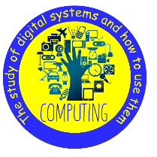 | Bletchley Park and the History of Computers |  | 1. Why was Bletchley Park important during World War Two?  Your child should explain that codebreakers at Bletchley Park helped crack secret messages and developed Colossus, one of the world's first electronic programmable computers.  2. How have computers changed over time?  Look for examples of early computers becoming smaller, faster and more widely used in homes, schools and workplaces.  3. Why is it important to use strong passwords?  Your child should explain that strong passwords help keep personal information safe and make it harder for hackers to access accounts. | Cipher (a way of writing information in a secret code)  CPU (Central Processing Unit) (the part of a computer that processes information and runs programs)  Password (a unique combination of letters, numbers or symbols used to keep information secure online)
  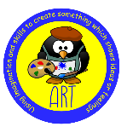 | Art: World in Watercolour |  | 1. What different things can an artist do with watercolour paint to create different effects?  Children might mention techniques such as wet-on-wet, wet-on-dry, layering, gradients and blooms, and explain the effects they create.  2. How can an artist use colour, texture and watercolour techniques to create a particular mood or idea?  Children might explain how artists choose colours and techniques to create a particular feeling or effect in their artwork. | watercolour – Transparent paint mixed with water to create different effects.  wet on wet – Adding paint to wet paper so the colours blend softly.  layering – Building up transparent layers of paint to create colour, tone and depth.
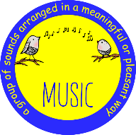 | Four Chord Pop: Playing in a Band |  | 1. What different musical parts might you hear when a band plays together?  Children might talk about the bass line, chords, melody and harmony, and explain how these parts work together.  2. What do musicians need to do to play successfully together in a band?  Children might explain that musicians need to listen to and look at each other, stay in time and use non-verbal cues to perform together. | melody – The tune; a pattern of different pitches.  chords – Two or more notes played at the same time.  harmony – Different notes played or sung at the same time.
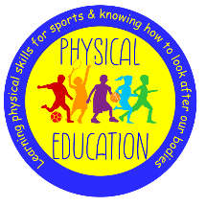 | Handball |  | 1.To receive the ball at varying heights using different techniques  Children will know to have a tight grip of the ball and get into a ready position for your next decision  Keep their arms pointing towards the ball and move towards as the ball travels • Know that as the ball is coming towards them, they start to move towards the ball  2.To effectively use the ‘rule of 3’  Understand when the need to dribble, pass or attempt to shoot  3.To defend successfully  Block a player and mark an area when defending • Know how to mark a player in handball • Try to regain possession of the ball by trying to step in front of the player to intercept it • Begin to anticipate and react to be able to intercept the ball  4. To attack and defend in competitive games  • Apply a range of different attacking and defending handball skills with some success • Understand and explain how tactics can be used to help win games and use them with excellent success  5 & 6. To take part in modified games of handball using the techniques learnt  Know when and where to use the different techniques learnt • Evaluate and improve their performance • Listen to others, express their own ideas and work well with others tactically | Throw  Catch  Intercept  Attack  Defend  Positioning  Tactics  Teamwork
 | This Is Me! |  | 1. Can you describe yourself in Spanish?  Your child should be able to say simple sentences about themselves, including their hair or eye colour and some of their personality traits.  2. How do you say "I am" and "I have" in Spanish?  Look for the answers soy ("I am") and tengo ("I have"), and ask your child to give an example of each.  3. Why do some Spanish words change when describing a boy or a girl?  Your child should explain that some adjectives change their ending (for example, -o to -a) to match whether they are describing a boy or a girl. | Soy (I am)  Tengo (I have)  Valiente (courageous/brave)  Soy valiente. (I am brave.)  Tengo los ojos azules. (I have blue eyes.)  Tengo el pelo castaño. (I have brown hair.)

