Books we’re reading | 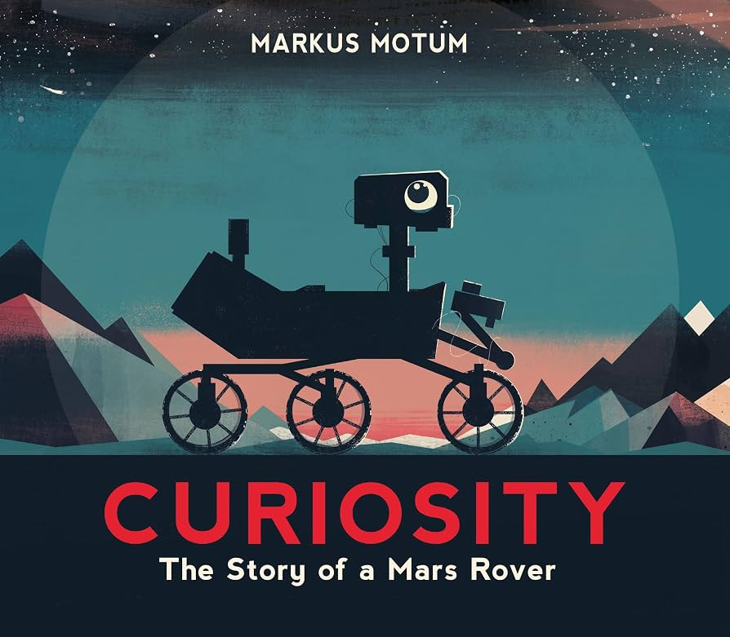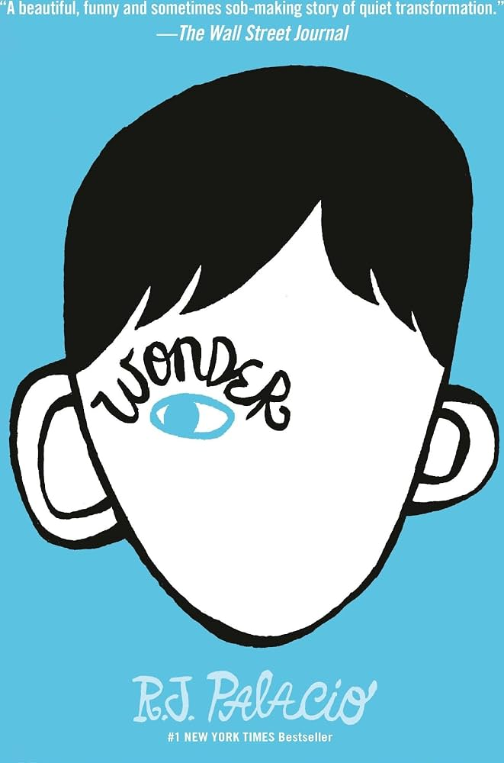
Music we’re listening to | 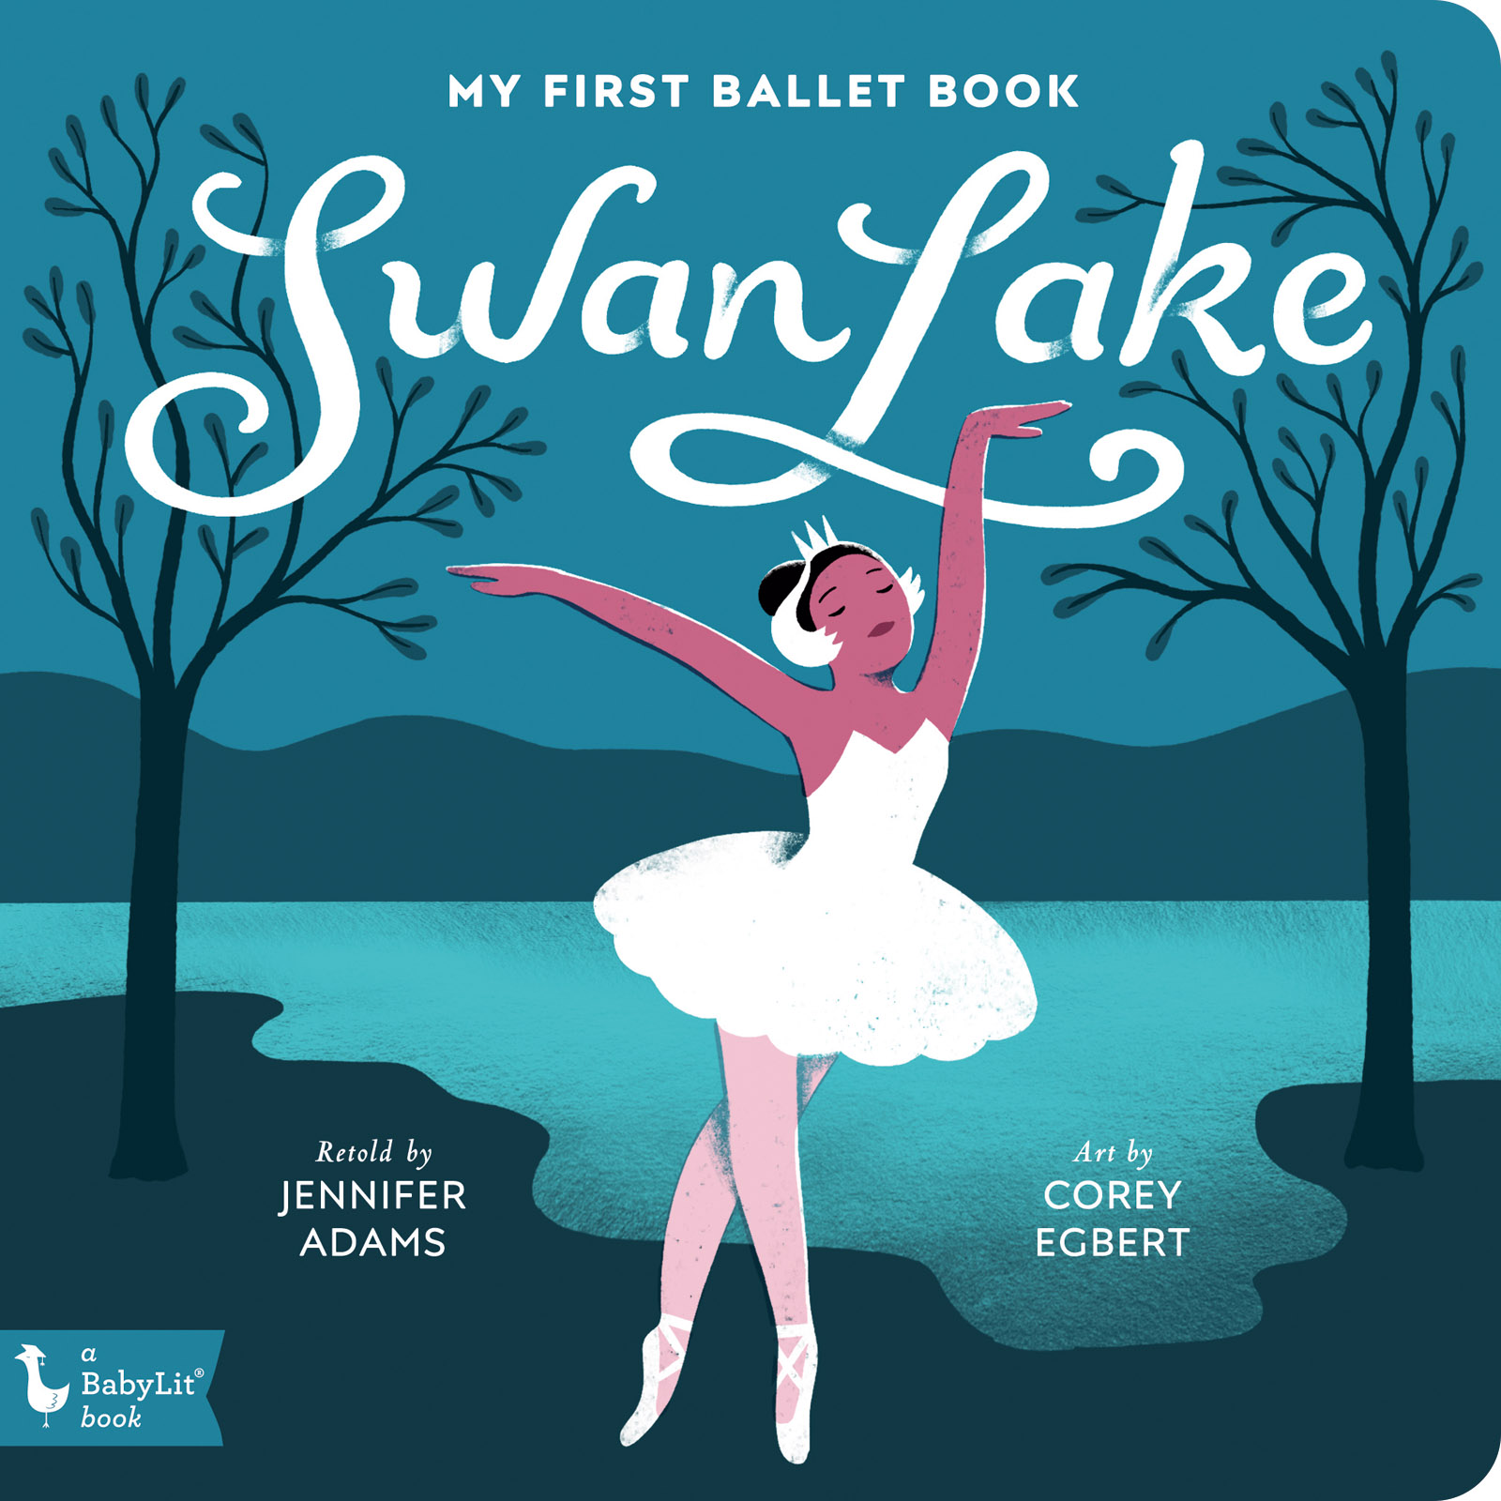
Whole school spoken Grammar Focus | Correct use of was and were (Click here for help with this)

Special Dates  For Year Five | Week beginning 7th September – School Council Elections  8th September – Meet the teacher 9:00am  15^{h} September – Meet the teacher 3:20pm  15th September – International Day of Democracy  19th October – Upper Key Stage Two Parent Workshop –3.30pm  19th October – 5 Juniper Reading Café – 2.45pm  21st September – Reading Buddies  21st September – International Day of Peace  Friday 25th September – Visit from local MP Elsie Blundell for question time and discussion about democratic systems  12th- 18th October – Road Safety Week  Highlighted dates have some parent involvement



 | Unit of work |  |  |  | Discussion points/ how to help at home | Vocabulary
 |  | Place Value within 1,000,000  Addition/ Subtraction  Multiplication/ Division |  | How many hundreds, thousands or tens of thousands are in this number?  How do you read this number out loud?  How can you partition this number in different ways?  If the digit is 7 in the ten thousandths column, what is its value?  What operation is needed and how do you know?  Which digits will you add first? Which place value do you work with first? |  | Partition- Splitting a big number into smaller chunks to make calculating much simpler.  Factors- A whole number that divides exactly into another number with no remainder  Multiples- the answer you get when you multiply a number by any whole number
 |  |  | Times tables practise |  |       (Please contact class teachers if you need any login details)
 | Curiosity  Space Journey Narrative  Formal Mission Log |  |  |  | Find a formal word or phrase: why has the author chose this instead of normal everyday language?  Why is it written is chronological order?  How does the use of precise times help the reader? | Chronological- putting things in the exact order that they happened, from start to finish  Keepsake- Something of sentinemntal value  Monograph- a detailed and documented treatise on a particular subject
   | History:  Were the Vikings raiders, traders or something else? |  |  |  | Where did the Vikings come from and why did they invade Britain?  How do we find evidence and make inference from sources?  Why were trade routes important to the Vikings?  What impact have Viking achievements had on modern day? | Settlers a person who moves to a new place or country to live, build a home, and start a community  Invaders- a person who moves to a new place or country to live, build a home, and start a community  Anglo-Saxons- a group of tribes (the Angles, Saxons, and Jutes) who travelled across the sea from Germany, Denmark, and the Netherlands to live in Britain
 | Forces and Space: Earth and Space |  |  |  | Can you describe the movement and shapes of the celestial bodies in our solar system?  Can you use temperature data to make predictions about climate change? | Celestial bodies any natural object that exists in space outside of Earth's atmosphere  Gravity an invisible pulling force that brings things toward each other  Testable something you can check, prove, or try out to see if it is true or false.
 |  |  | Changing Me |  | Being me in my world  Can you describe your role in the world?  Can you develop your aspirations as you get older and justify how they will positively impact the world in the future?  Can you explain why it is important to have a sense of belonging? | Individuality the special combination of your thoughts, feelings, looks, and the things you love to do  Community a group of people who live, work, or play together, or who share the same interests, beliefs, or hobbies  Society a large group of people who live together in the same area, like a country or community, and share the same laws, customs, and resources.
 |  |  | Relate  Engage  Transition
 | What does it mean to be a Muslim in Britain today? |  |  |  | How do Muslims pray and why is it important?  How do people that believe in Islam celebrate their religion?  What are the joys and challenges of being Muslim in Britain? | Allah The Arabic name that Muslims use for God.  Prophets Special messengers sent from Allah.  Ramadan A Muslim festival where Muslims choose to not eat (fast)  during daylight hours. This lasts for 30 days.  Pilgrimage A journey to a special place of religious meaning.
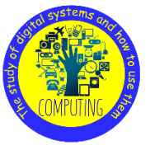 | Computing Systems and networks  Search Engines |  |  |  | What is a search engine and how do we use them to find websites and information?  Recognise that not everything online is true and what to check for.  What is copywriting and fair use? | Search Engine- a specialized internet search tool designed to protect children from inappropriate content while helping them find age-appropriate information, images, and videos  Algorithm simply a step-by-step set of instructions or rules used to solve a problem or complete a task.  Index explains complex words or concepts using simple, everyday language that is easy for kids to understand
   | DT  Electrical Systems: Wobblebots |  |  |  | Can I identify simple elements in a circuit?  Do I understand that for electricity to flow in a circuit, the circuit must be closed?  Can I design a motorised product for a particular purpose? | Annotate to add helpful notes, comments, or explanations to a piece of writing, a diagram, or a picture  Assemble to bring people or things together into one place, or to put pieces together to build something whole  Electrical Component any individual part or "building block" inside an electrical circuit that performs a specific job.
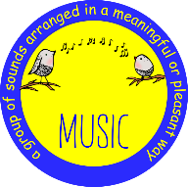 | Tell the story of a journey effectively and perform smoothly as a group? |  |  |  | Can you sing with accuracy, fluency, control and expression?  Can you explore and use different forms of notation?  Can you understand note length?  Can you use hieroglyphs to stave notation to write a piece of music? | Composition how things are put together, made, or created  Ensemble a group of things or people that work together to create a single, complete unit  Pitch notation is simply the way we write these sounds down so musicians can play them later
 | Handball |  |  |  | What are the rules of Handball?  How are points scored in Handball?  How can we work as a team in Handball? | Jumpshot a move in basketball where a player leaps into the air and throws the ball toward the basket at the very top of their jump  Dribbling continuously bouncing the ball off the floor with one hand as you run or walk  Three-step rule when a player is holding the ball, they are only allowed to take a maximum of three steps before they have to pass, shoot, or bounce (dribble)
 | Me and my friends at school |  |  |  | How do I say how I am feeling?  How do I describe my favourite subjects?  How do I say where I am from? | Ingles  Mathematicas  Historia  Geographia  Arte  estoi

