Special Dates  For Year 4 | Week beginning 7th September – School Council Elections  8th September – Meet the teacher 9:00am  15th September – International Day of Democracy (covered in school)  15th September – Meet the teacher 3:20pm  21st September – International Day of Peace (covered in school)  12th- 18th October – Road Safety Week  Highlighted dates indicate parental involvement

Books we’re reading | How to train your dragon  The Whale
Music we’re listening to | 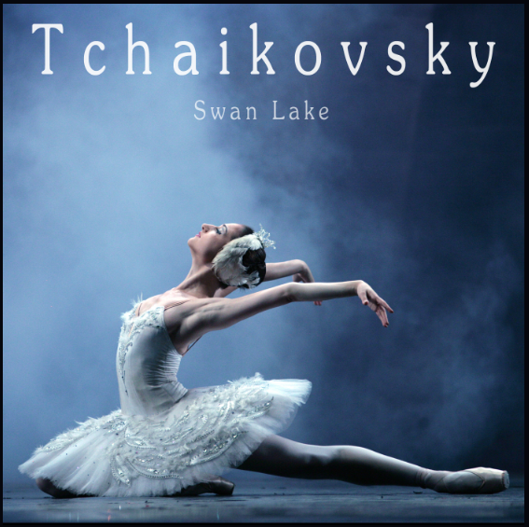
Whole school spoken Grammar Focus | I went park. ❌  I went to the park. ✔️



Autumn 1 2026
Term Begins: Thursday 3rd September
Term ends: Thursday 22nd October

 | Unit of work |  | Discussion points/ how to help at home | Vocabulary
 |  | Unit 1: Place Value 4 digit numbers  Unit 2: Addition and subtraction | - Parents can support children with 4-digit place value by practising little and often and using everyday objects to make the numbers meaningful.  At-home activity: “Build the Number”  Choose a 4-digit number, for example 3,426.  Ask your child to:  Say the number aloud: three thousand, four hundred and twenty-six.  - Identify the value of each digit: 3 thousands, 4 hundreds, 2 tens and 6 ones.  - Make the number using objects such as coins, Lego, pasta or drawing blocks.  - Write the number in expanded form: 3,000 + 400 + 20 + 6.  - Change one digit and ask, “What is the new number? What has changed?”  Make it a game: Write the digits 0–9 on separate pieces of paper. Take four cards and arrange them to make the largest number possible, then the smallest number possible. Challenge your child to explain the place value of each digit.  This helps children understand that a digit's value depends on its position, rather than simply memorising the place-value columns. | Thousands (1000s), Hundreds (100s), tens (10s), ones (1s), place value, partition, number line, multiples, digit
 |  | N/A  Scheme begins in January |       (Please contact class teachers if you need any login details)
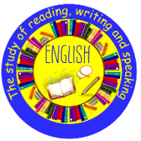 | The Whale by Ethan and Vita Murrow  Writing Outcome:  Setting narrative  Newspaper report |  | Use the BBC bitesize website to explore grammatical features such as similes, expanded noun phrases, speech punctuation and fronted adverbials that will be covered in our narrative writing.  https://www.bbc.co.uk/bitesize/topics/zwwp8mn  A simple activity is a “Story Setting Detective” game.  - Choose a short story or picture book with your child.  - Read a section together and ask: “Where is the story happening?”  - Help your child identify clues about the setting, such as the place, time, weather, and surroundings.  - Draw a picture of the setting together and label important details.  - Ask questions such as:  - “What can you see there?”  - “What would you hear?”  - “How do you think the character feels in this place?”  - “Would the story be different if it happened somewhere else?”  This helps children understand that the setting is where and when a story takes place, which they can then apply when identifying settings in stories at school.  Choose an interesting image from the following website; https://www.pobble.com/  - “Make Your Own Newspaper Report.”  - Find a simple news story together, or choose a pretend event such as “The School Fair Was a Huge Success!”  - Ask your child to identify the 5 Ws: Who, What, Where, When and Why.  - Together, create a newspaper report with:  - A headline  - An opening sentence summarising the main event  - The important facts using the 5 Ws  - A short quote from someone involved  - A picture with a caption  - Encourage your child to use past tense, factual language and time words such as yesterday, later, and afterwards.  - Let your child read their finished report aloud as if they were a news reporter.  This will help them recognise and use the key features of a newspaper report, making it easier to complete similar writing tasks independently at school. | Narrative, adjective, noun, verb, prefix, suffix, simile, fronted adverbial
  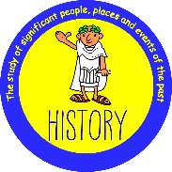 | History: How have children’s lives changed? |  | What do sources tell us about how children’s lives have changed? How has children’s leisure time changed? Talk to your child about your childhood and how it may be different to theirs.  Why did Tudor children work? What were children’s jobs like in Victorian times? Ask how children’s work differed in Victorian times to Tudor.  Who was Lord Shaftesbury? Answer: https://www.bbc.co.uk/programmes/p011lqq9  What were the diseases children caught and how were they treated? | apprentice  childhood  class  continuity  deduction  law  master  modern  poorer  poverty  servant  significance  wealthier  working conditions
 | Animals including Humans: Digestion and Food |  | The human digestive system  Human teeth – What are the names of the different teeth and what are their jobs?  Teeth of carnivores, omnivores and herbivores – What are these type of animals? | canine  molar  pre molar  incisor  oesophagus  digest  stomach  carnivore  omnivore  herbivore
 |  | Being me in my world | 1. Becoming a Class ‘Team’  Included, Excluded, Welcome, Valued, Team, Charter  - Being a School Citizen  - Rights, Responsibilities and Democracy  What does rights, responsibilities and democracy mean in school and in the wider setting  4. Rewards and Consequences  What actions should be rewarded in the classroom and looking at consequences for not doing the right thing  5. Our Learning  Charter  Making a learning charter together for the classroom and looking at the school charter  6. Owning our Learning Charter  Making decisions, having a choice, what does democracy mean and the UN Convention on Rights of the child | - Decisions  - Rights  - Responsibilities  - Voting  - Democracy  - Authority  - Learning Charter  - Role  - Contribution  - Observer  - Reward  - Consequence  - Democratic
 |  | Meet your brain | Hippocampus – stores our memories.  Amygdale – Fight, flight or freeze.  Prefrontal cortex – helps us to problem solve and make decisions.  (Team H-A-P)  Try out some ‘Happy Breathing’ at home. Happy Breathing is when we notice our amygdala has taken over and we take slow and intentional deep breaths ensuring that are brain gets the oxygen it needs – once this happens we slowly come out of the ‘fight, flight or freeze’ response and Team H-A-P can work together again.
 | Why is Jesus inspiring to some people?  RE Today Unit 28 |  | What does the word ‘inspiring’ mean? Who is inspiring?  Who is inspiring?  Talk about heroes and inspiring people. Use the word ‘inspired’ in an appropriate way. Choose some inspiring people of their own.  What do we know about Jesus’ life story? Is his story inspiring for some people?  Was Jesus inspiring because of his actions?  Retell the story of feeding 5000, one of Jesus’ miracles | Inspire  Inspiring  hero
 | Computing systems and networks: Collaborative learning  Opt1: Google |  | Developing collaborative working skills through using online software to create and share digital content  - Understand the need to be thoughtful when working on a collaborative document.  - Use comments to suggest changes to a document and understand how to resolve comments.  - Use a variety of different slide styles to convey information, including images and transitions.  - Create a Google Form with a range of different question types that will provide different types of answers, e.g. text, multiple choice or numerical values.  - Export data to a spreadsheet, highlighting data, using conditional formatting and calculating averages and sums of numbers. | Email  Spreadsheet  Surveys  Numerical data  Multiple choice
  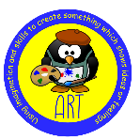 | Drawing: Exploring tone, texture and proportion |  | Exploring tone, texture and proportion to create realistic and expressive drawings, inspired by artists Sarah Graham, Nicola McBride and Beatriz Milhazes.  To develop their techniques, including their control and their use of materials, with creativity, experimentation and an increasing awareness of different kinds of art, craft and design.  Encourage children when drawing at home to remember what they have been taught this term to improve their creative drawings | collage  composition  form  highlight  proportion  shadow  three-dimensional
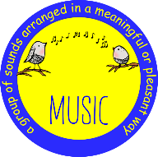 | Samba and Carnival sounds |  | Appreciate and understand a wide range of high-quality live and recorded music drawn from different traditions and from great composers and musicians.  Listen with attention to and recall sounds with increasing aural memory  Play and perform in solo and ensemble contexts, using their voices and playing musical instruments with increasing accuracy, fluency, control and expression | - Brazil, Carnival,  - Samba Batucada,  - Bateria, Cowbell, Agogo  - Chocalho, Ganza Caixa  - Surdo,Tambourim,,  - Repinique, Rhythm Texture, Dynamic,  - Structure
 | Swimming |  | This term Year 4 will be taught by a qualified PE coach on a Thursday  This term Year 4 will be going swimming on a Friday
 | Welcome to School |  | Welcome to school (Recap core language, rooms in a school, classroom objects)  Greetings  To ask and answer questions about myself in Spanish  Numbers 1  To recall numbers 1- 10 and some classroom instructions  To say and read numbers 1 – 20  Days and Months  To learn and recall days and months of the year  Rooms in school and classroom objects  To say and write nouns for some classroom objects in Spanish and to learn the name of different rooms in school

