Books we’re reading | 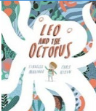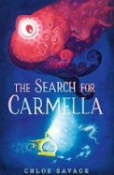
Music we’re listening to | 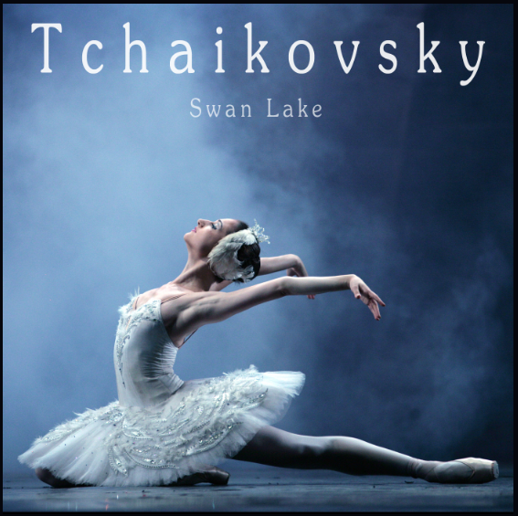
Whole school spoken Grammar Focus | I went park. ❌  I went to the park. ✔️

Special Dates  For Year 2 | 8th September – Meet the teacher 3.20pm  15th September – International Dot Day (covered in school)  15th September – Meet the teacher 3:20pm  21st September – International Day of Peace (covered in school)  12th- 18th October – Road Safety Week  Highlighted dates indicate parental involvement



 | Unit of work |  | Discussion points/ how to help at home | Vocabulary
 |  | Numbers to 100 | Can you count from 36 to 56 without missing any numbers? Can someone check your counting?  Can you use a place value grid to show the number 74? How many tens and how many ones does it have?  Can you put these numbers in order from smallest to largest: 48, 19, 82, 65? How do you know your order is correct? | Tens – A group of 10 ones. For example, in 43, there are 4 tens (40).  Ones – Single units. For example, in 43, there are 3 ones.  Partition – To split a number into smaller parts to help us understand or work it out. For example, 67 can be partitioned into 60 and 7 (6 tens and 7 ones).
 |  |  |   (Please contact class teachers if you need any login details)
 | Leo and the octopus  The search for Carmella |  | What type of writing is it and what is the purpose?  What is the grammar focus?  What is the punctuation focus?  What new words have you learned? | Texture – How something feels or looks like it would feel. It can be smooth, rough, bumpy, soft, or hard.  Determined – Not giving up, even when something is difficult.
  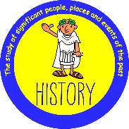 | History:  How was school different in the past? |  | What questions would you ask to find out what school was like 100 years ago, and what sources could help you answer them?  What are two similarities and two differences between schools 100 years ago and schools today? Which school would you rather attend, and why?  Would you have preferred to go to school 100 years ago or today? Can you give two reasons to explain your choice? | Past - Time that has already happened.  Present - Time happening now.  Timeline - A line showing events in time order.
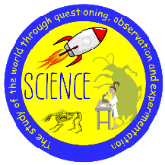 | Living Things - Habitats |  | What do plants and animals need to stay alive, and how are their life processes different?  Can you match different plants and animals to the habitats where they live, and explain how those habitats provide food and shelter?  Can you draw a simple food chain, placing the producer at the beginning and using arrows to show how energy moves from one living thing to the next? | Life processes - The things every living thing does.  Analyse - Looking at evidence to find links and patterns.  Classify - To sort things into named groups.
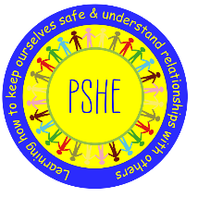 |  | Being me in my world | What are your hopes and goals for this school year, and what could you do if you feel worried or need help?  How can you help everyone feel welcome and included in your class, and why is it important to follow the Learning Charter?  What choices can you make to help keep your classroom safe and fair, and what are the consequences of making good or unhelpful choices? | Assertive – Speaking up for yourself in a kind and respectful way.  Belonging – Feeling like you are an important part of a group, such as your family, class, or school.  Boundaries – Rules or limits that help keep everyone safe and happy.
 |  | Relate  Engage  Transition
 | Who is a Christian and what do they believe? |  | Why did Jesus choose Matthew the tax collector and the fishermen to be his Apostles, even though they were unlikely choices?  What does Jesus’ message of love, forgiveness and peace teach Christians today, and how can people show this in their everyday lives?  How are Christians today, such as those who help at St. George’s Crypt, following Jesus’ example of forgiving, helping others and being world changers? | Christians - People who follow Christianity and believe Jesus is the Saviour who healed the rift between humanity and God.  Jesus - A very important person for Christians; God in the flesh
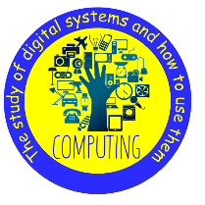 | What is a computer? |  | Can you name some parts of a computer (such as a keyboard, mouse and screen) and tell us what they do?  What happens when you press a button on a piece of technology, and how does a computer know what to do?  Can you draw your own technology invention and explain what goes in (input), what comes out (output), and how it could help people? | Computer - An electronic machine that accepts and processes information to produce an output and then stores the results.  Desktop - A tower computer that stays in one place and needs a mouse, keyboard and monitor.
   | Art and Design:  Drawing: Understanding tone and texture |  | Can you use different pencils or drawing tools to make light, dark, thick and thin marks, and describe the texture of an object you have drawn?  How can you use shading to make a drawing look more real, and why do artists use tone in their work?  Can you lightly sketch an object first, then improve your drawing by changing the outline? Can you also make a facial expression and pose to show a feeling in a photograph? | Shadow - A dark shape that appears when something blocks the light.  Tone - How light or dark something is.
 | Intro to games |  | Can you dribble a ball with your feet or your hands while keeping it under control? Which do you find easier, and why?  How can you pass the ball, protect it from a defender, or move around a defender during a game?  Why is it important to follow the rules of a game, and how do you know which skills or techniques to use in different games? | Technique - the specific physical movement or "how-to" required to perform a sports skill  Control - the ability to effectively manage, restrain, and direct your body movements or equipment (like a ball) during a physical activity

