Books we’re reading | 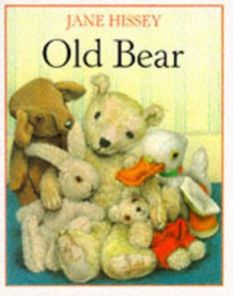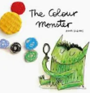
Music we’re listening to | 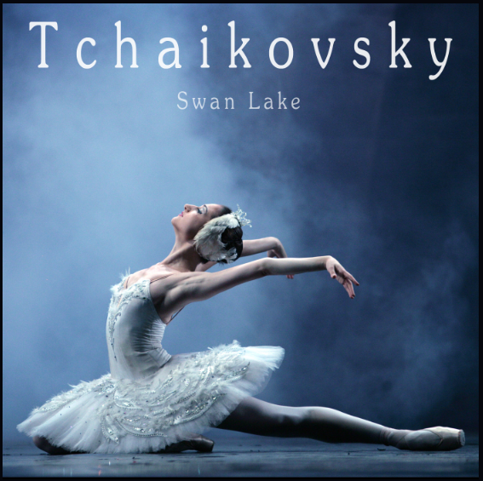
Whole school spoken Grammar Focus | I went park. ❌  I went to the park. ✔️

Special Dates  For Year 1 | 8th September – Meet the teacher 3.20pm  15th September – International Dot Day (covered in school)  15th September – Meet the teacher 3:20pm  21st September – International Day of Peace (covered in school)  12th- 18th October – Road Safety Week  Highlighted dates have some parent involvement

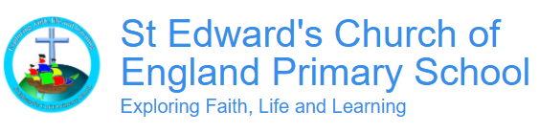
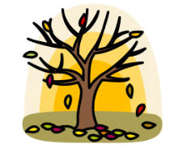

Autumn 1 2026
Term Begins: Thurs 3rd September
Term ends: Thursday 22nd October

 | Unit of work |  | Discussion points/ how to help at home | Vocabulary
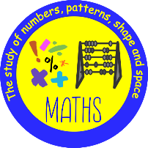 | 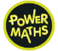 | Numbers to 10 | Can you count in order to 10? Can you count a number of objects to 10?  Can you put numbers in order to 10?  Can you show different ways to represent a number? (i.e. 3, ***, 3 fingers, ///, …)  Can you count on from 4 all the way to 10?  Which is the largest number, 5 or 7?  Can you put in order from smallest to largest: 6, 3, 7, 9?  What is 1 more than 8? What is 1 less than 5?  Can you count backwards from 10 to 0? | Sorting - putting objects into groups based on something they have in common (e,g. size, colour, shape, kind).  Count on – Count forwards by ones (or using fingers, a track, or a number line) from a specific number.
 |  | Subitising from 1 to 10 | Flash-and-Tell: Show a flashcard with dot patterns, dice faces, or finger gestures for just two to three seconds. Can you say what number this is?  Your child should be able to say the number of objects they see without needing to count them.  Object Sort: Gather small groups of everyday items—like buttons, cubes, or toy cars—in random arrangements. Can you say how many objects there are without counting?  Your child should be able to say how many items are in a group without pointing or touching them one by one. | Subitising - the ability to look at a small group of items and instantly know how many there are without counting them.
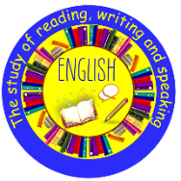 | Old Bear- Jane Hissey |  | Old Bear- Jane Hissey  Purpose: sentence writing- story retell  Grammar focus: adding ‘s’ or ‘es’/ Capital Letters for names/ Using ‘and’  Punctuation focus: capital letters/ full stops/ separation of words with finger spaces  New words we are learning: marvellous/wobble/collapsed/bounced/dangerous/whizzed/muffled/  Propped/ tumbling | Sentence- A group of words that make sense on their own, conveying a thought or idea  muffled- A sound that is quiet or not clear, like when you cover your mouth to speak.  Propped- When you lean or rest something against something else to keep it up.
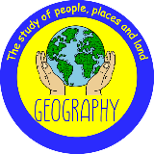  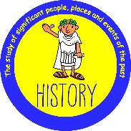 | Geography  What is it like here? |  | What does UK stand for, and what is the name of the country we live in?  Your child should be able to explain that we live in England which is part of the United Kingdom.  What is an aerial photograph, and how is it different from a photograph taken from the ground?  Your child should be able to explain that an ariel picture is taken from above the ground and be able to give examples of how things might look different from the air.  What is a map used for, and what do symbols on a map help us to find?  Your child should be able to explain that a map is used to locate different places and features ie: land & sea. They should also be able to explain the meaning of simple map symbols such as church and campsite. | Aerial view- A view or photograph of a place taken from above. Country- A country is a land or nation with its own government. Map- A map is a picture of a place, usually drawn from above.
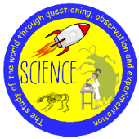 | Everyday Materials |  | Can we make a raincoat out of paper?  Your child should be able to talk about materials that would make a suitable raincoat and be able to say why paper would not be suitable.  Why do we use glass as a material for windows?  Your child should be able to talk about how some materials are transparent and can be seen through and how others are not.  Which of these objects are soft to the touch: a rock, a metal spoon or a teddy bear?  Your child should be able to talk how the teddy bear is soft to the touch and how the other materials are hard. | Object – something that can be seen or touched.  Material – what objects are made from.  Waterproof – stops water getting through.  Absorbent – soaks up and holds on to water.
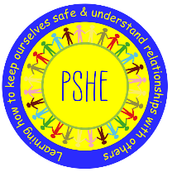 |  | Being Me in My World | What helps you feel calm if something feels tricky?  Your child should be able to give examples of things they could do to help themselves remain calm ie: deep breathing, doing something they enjoy  What things have you done that you are proud of?  Your child should be able to talk about something that they have achieved and how this made them feel | Achievement - something achieved through hard work, courage, or skill.  Responsibility - something achieved through hard work, courage, or skill.
 | 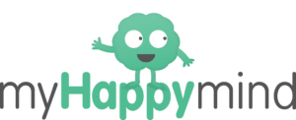 | Meet Your Brain | What can you do help you relax?  Your child should be able to give examples of ways they can relax such as: taking deep breaths, listening to music, having quiet time or doing something they enjoy.  Can you show how to do your Happy breathing?  Your child should be able to actively demonstrate breathing techniques they have learnt in class. | Hippocampus – part of the brain that stores our memories and things we learn.  Amygdala – it is the part of the brain that reacts to keep us safe by Fighting, Flitghting or Freezing.
 | Who is a Christian and what do they believe? |  | How does God show that He loves people?  Your child should be able to talk about how God is forgiving and that he shows his love by caring for us.  What does the story of The Lost Son teach Christians about forgiveness?  Your child should be able to explain that the story teaches Christians that God forgives us when we make mistakes and welcomes us back with love.  How does the story of The Lost Sheep show that God cares for everyone?  Your child should be able to talk about how the story shows us that God cares about everyone and will not give up on anyone who is lost. | Holy: something that is considered to be good because it relates to religion Forgiving: stopping blaming or punishing someone for that they have done  Worship: to praise and follow God  Loving: the act of taking care of something or someone because of a strong attachment  God: the all loving and all powerful being that Christians believe created the world and everything in it
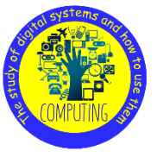 | Computing systems and networks  Improving mouse skills |  | Why do we log in and log out of a computer?  Your child will be able to explain that we log in and out of a computer to tell it when we are ready to start or finish with it.  What can you use a computer mouse to do?  Your child will be able to explain some functions that a mouse can be used for ie: clicking, dragging, filling, selecting, adding clipart, adding text  Why is it important to keep your password safe?  Your child should be able to explain that passwords used are for our security and safety and should be kept to ourselves. | Account- Somewhere our information can be stored and seen safely.  Login- A username and password unique to you, to access your personal account.  Mouse- A device that is used to move things around on the computer screen.  Password- A secret word made up of letters, numbers and symbols.
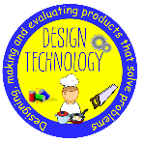  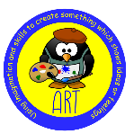 | Design Technology  Stable Structures |  | What is a structure, and what makes it stable?  Your child should be able to explain that a structure is something that is made and put together for a purpose. They should also be able to suggest that adding a wide flat base or adding a weight to a structure will make it more stable.  What are some common craft tools, what are they used for, and which ones are sharp?  Your child should be able to name some craft common tools such as scissors/ glue and pencils  What will you make and why, and how can your drawings show your ideas?  Your child should be able to talk about the pencil pot they are going to make and the purpose it will have ie: storing pencils safely. They will also be able talk about their design ideas. | Structure-something that is built to do a job. Stable- Not likely to topple over. Design-To make, draw or write plans for something. Product-something that people make to use or sell.
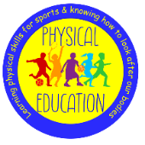 | Fundamental skills-moving |  | Can you show me how you can travel in different directions?  Your child should be able to move their body in differing directions using a variety of body parts to do this.  Can you change the way you are travelling while staying in control?  Your child should be able to switch the direction and way they are moving, whilst keeping control of their body and their balance.  Can you show me how to hop, bounce and skip and use different body parts to move in different directions?  Your child should be able to hop, bounce and skip and use their body to travel in any direction. | Space- the area around you that you can move safely in. Control- moving your body carefully and staying balanced. Balance- keeping your body still and steady. Teamwork- helping and working together with others

