Special Dates  For Reception | 07.09.26-Meet the Teacher (Tuesday) 3.30pm  Or  14.09.25 – Meet the Teacher (Tuesday) 3:30pm  Prior Notice  8.12.26 - Nativity for parents 2:15pm  9.12.26 – Nativity for parents 2:15pm

Our Author of the term:  Jill Murphy | 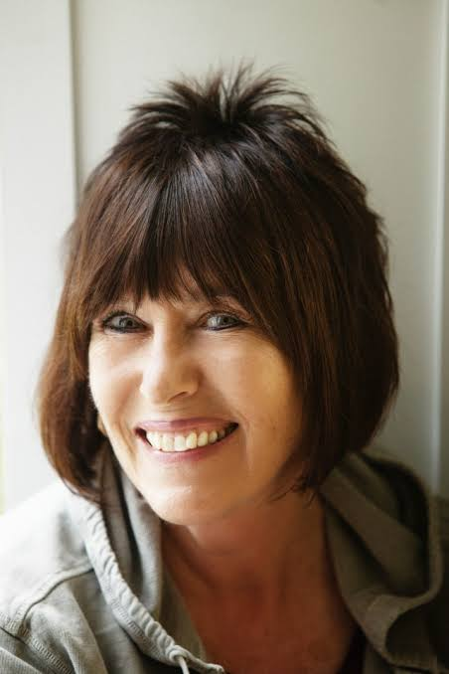
Music we’re listening to | 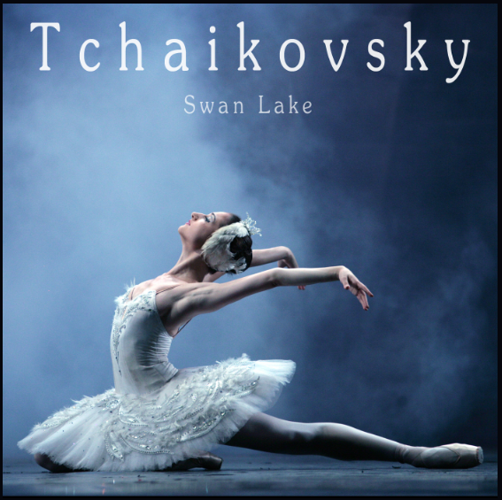
Whole school spoken Grammar Focus | I went park. ❌  I went to the park. ✔️



 | Unit of work |  | Discussion points/ how to help at home | Vocabulary
 |  | Numbers to 5  Comparing groups within 5 | Count forwards and backwards to 5.  Discuss different amount up to 5. | Count, count forwards, count backwards, how many, total, altogether, five frame, same, different, next, after, arrange, more, fewer, represent, match, sort, compare, equal.
 |  | Cardinality and Subitising  subitising 1 and 2  subitising 1 to 3  subiting 1 to 4 | Looking at and recognising numbers 1-4 in lots of different ways.  Ask children what they can see?  Look at numbers in the environment e.g. door numbers, at the supermarket. | 1, 2, 3, 4  How many  What can you see?
 |  |  | Read stories together.  Play eye spy and look at the initial sound of a word e.g. snake starts with ‘s’ | Story  First sound
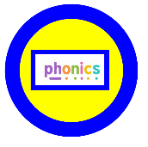 | 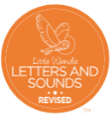  Phase 1 sound games, sounds and rhymes.  Phase 2 (week 3)  s,a,t,p,i,n,m,d,g,o,c,k  ck,e,u,r,h,b,f,l  tricky words – is, I, the |  | Practice taught sounds at home.  Read taught tricky words at home. | Phoneme  Grapheme  Tricky word  Initial sound
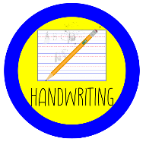 |   Dough disco  Squiggle while you wiggle  Developing pencil grip: using clockwise/ anticlockwise movements. |  | Play with playdough to strengthen hand muscles.  Use Little Wandle rhymes to practice letter formation.  Encourage children to write letters using an anti-clockwise motion.
     | History & Geography  Talk about changes from being a baby to now.  Talk about their families.  Look at school community  Look at wider community and people who help us |  | Share photos with children of them as a baby, family members as a baby and how they change when they grow up. | Family  Change
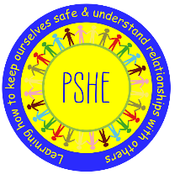 |  | Being me in my world | Talk to children about settling into school and why rules and routines are important. | Nervous  Different  Responsibility
 |  |  |  | Nervous  Different  Responsibility
 | Where do we belong?  RE Today Unit 3 |  | Talk to children about being part of a family.  Discuss with children about being part of a club or faith. | Muslims  Hindu  Christians  Jesus  Baptism  Welcome  Love  Special
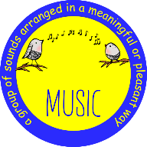 |   Music and Movement |  | Practice a variety of action songs at home, e.g. heads, shoulders, knees and toes.  Clap to the beat of a song. | Actions  Lyrics  Beat
 |   Moving – fundamental skills |  | Practice jumping and landing with two feet together.  Practice skipping. | Jump  Skip  Faster  Slower

