
Books we’re reading
Music we’re listening to
Whole school spoken Grammar Focus | Correct use of was and were (Click here for help with this)

Special Dates  For Year Six | 5th June – Spanish Day  5th June – Y5/6 Interhouse swimming gala  8th – 10th June – Robinwood Trip/ Fun activities  Week beginning 15th June – Refugee Week  18th June – Parent Workshop (2.45-3.20)  19th June – Music Day  26th June – Y6 fun swim  Week beginning 29th June – Health Week  1st July – 2 end of year performances for parents (afternoon and evening)  7th July – Transition Day  9th July – PTA Colour run and fair (5.15pm)  15th July – Y6 Leavers’ Service at St Martin’s Church (10am)  17th July – Leavers’ Assembly (9.15am)


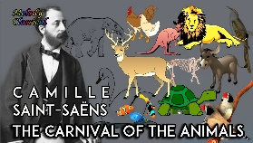


 | Unit of work |  | Discussion points/ how to help at home | Vocabulary
 |  |  | Problem solving- how can you solve these puzzles and problems?  Can you teach different methods to others?  How far can you make £5 stretch? | Profit  Loss  Income generated  Logical steps
 |  |  |       (Please contact class teachers if you need any login details)
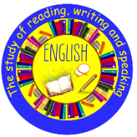 |  |  | What type of writing is it and what is the purpose?  What is the grammar focus?  What is the punctuation focus?  What new words have you learned? | WW2  Senses  Emotions  Battlefield
  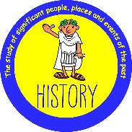 | Geography:  Can I carry out an independent fieldwork enquiry? |  | What question are you trying to answer in your fieldwork enquiry, and why is it important?  Which data collection method (such as questionnaires, photographs, tally charts, or interviews) do you think was most useful, and why?  What improvements would you suggest for the local area after analysing your fieldwork findings? | Data collection methods (a particular way to collect specific data)  Enquiry (an investigation into a question)
 | Circulation and Health |  | 1. Question: What does the heart do in your body?  Answer: The heart is a pump. It pushes blood around the body through blood vessels.  2. Question: What happens to your heart rate when you exercise?  Answer: Your heart rate gets faster during exercise because your body needs more oxygen and energy. | Circulatory system (the group of organs responsible for transporting blood around the body)  Blood vessels (the tubes that blood flows through around the body)
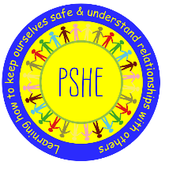 |  | Changing Me | Why is positive self-esteem important, and how can we challenge negative ‘body-talk’?  What changes are you looking forward to — or worried about — as you become older and move to the next year? | Self-esteem (how much you appreciate and like yourself)  Neuroplasticity – your brain can grow and change when you practise something)
 |  | Relate  Engage  Transition
 | What can be done to reduce racism? Can religion help? |  | How do different religions encourage people to treat others fairly and kindly?  What should we do if we hear someone being unfair or unkind because of another person’s race or religion?  How can learning about different cultures and religions help reduce racism? | Prejudice (an opinion that is formed without knowing or considering all the facts)  Discrimination (acting on prejudice)
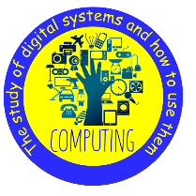 | Big Data  Exploring AI |  | How is AI already helping people in everyday life, and where have you seen it being used?  Why is it important to think carefully about whether AI-generated text or images are authentic or trustworthy? | Code (instructions written for computers)  Modify (to change or alter something)
   | Sculpture and 3D: Making Memories |  | How can artists use everyday objects to create meaningful sculptures or assemblage art?  What is the difference between literal and abstract sculpture, and which style do you prefer? Why?  How can memories, feelings, or personal experiences inspire 3D artwork? | Assemblage (a collection of things)  Juxtaposition (placing two things next to each other to show contrast or make people think)
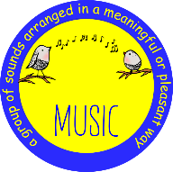 |   End of year performance |  | We use our end of year performance as an opportunity to build confidence in singing and performing together with accuracy and expression. They develop listening skills and an understanding of different musical styles and history.  We look forward to inviting you to our performance! | Downstage (the area of stage closest to the audience)  Upstage (area of the stage furthest from the audience)
 | Athletics  Jag Tag |  | How can changing speed, direction and movement patterns how you move more effectively?  How does the correct throwing technique help you throw further?  How can you work as a team to attack and defend? | Stamina  Technique  Attack  Defend  Zone marking
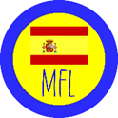 | Tapas Culture  Let’s Celebrate! |  | Why do you think tapas culture in Spain is often about sharing food and spending time together?  Which tapas dishes or drinks would you like to try, and why?  How is eating at a tapas café similar to or different from eating out in our own culture? | Guest: ¡Hola! Estoy muy bien, gracias. ¿Y tú? • Waiter/waitress:¿Qué querías? • Guest: Quería una tapa de ________ y __________, por favor. •

