Books we’re reading | 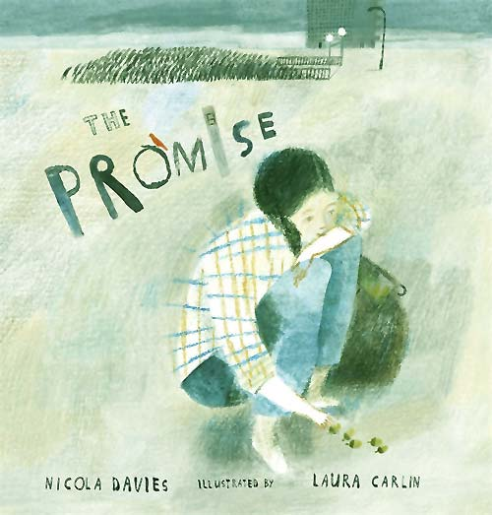
Music we’re listening to | 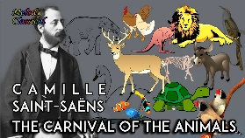
Whole school spoken Grammar Focus | Correct use of was and were (Click here for help with this)

Special Dates  For Year Six | 5th June – Spanish Day  5th June – Y5/6 Interhouse swimming gala  8th – 10th June – Robinwood Trip/ Fun activities  Week beginning 15th June – Refugee Week  18th June – Parent Workshop (2.45-3.20)  19th June – Music Day  26th June – Y6 fun swim  Week beginning 29th June – Health Week  1st July – 2 end of year performances for parents (afternoon and evening)  7th July – Transition Day  9th July- Year 5 Trip: Science and Industry Museum  9th July – PTA Colour run and fair (5.15pm)  15th July – Y6 Leavers’ Service at St Martin’s Church (10am)  17th July – Leavers’ Assembly (9.15am)




 | Unit of work |  | Discussion points/ how to help at home | Vocabulary
 |  | Geometry  Decimals  Measure | How can you use knowledge of angles, lines, and shapes to solve geometry problems in real life situations?  How do decimals help us measure length, mass, and capacity accurately, and when might we use them in everyday life? | Parallel Refers to lines that are the same distance and never intersect  Perpendicular Two lines, planes, or surfaces that meet or intersect at a perfect right angle
 |  | Times tables practise |       (Please contact class teachers if you need any login details)
 | The Promise  Write a narrative poem |  | What are the key features of a narrative poem, and how does it tell a story to the reader?  How can a poet use rhyme, rhythm and descriptive language to make a narrative poem more exciting and engaging? | Stanza A grouped set of lines within a poem, usually separated from others by a blank line or indentation  Rhyme The repetition of identical or similar sounds at the end of words
   | Geography:  Would you like to live in the desert? |  | At which lines of latitude are most hot desert biomes located, and why are deserts commonly found there?  What are the main characteristics of a hot desert biome, and how do humans use desert environments such as the Mojave Desert? | Biome A large distinct geographical region of earth with unique climate, soil, plants and animal life.  Agriculture The science, art and practice of cultivating soil, producing crops and raising livestock.
 | Mixtures and Separation |  | What is a mixture? How can methods such as sieving, filtering and evaporating be used to separate different types of mixtures and solutions?  How does temperature affect the time taken for a substance to dissolve? What variables should be changed, measured and controlled when investigating this scientifically? | Crystallising Where a solid forms with highly organised molecules  Evaporation The physical process where a substance changes from a liquid to a gas.  Dissolving The process where a solid liquid or gas (solute) mixes into a liqud.
 |  | Changing Me | Why is positive self-esteem important, and how can we challenge negative ‘body-talk’?  What changes are you looking forward to — or worried about — as you become older and move to the next year? | Self-esteem (how much you appreciate and like yourself)  Neuroplasticity – your brain can grow and change when you practise something)
 |  | Relate  Engage  Transition
 | Creation and science; conflicting or complementary? |  | What are the relationships between religious belief and scientific understanding?  What is the Christian creation narrative found in Genesis and the scientific theories of the Big Bang and evolution?  What does it mean to be made in the image of God and What responsibilities does that give to humans? | Genesis: the first book of the Bible and  Torah which includes God creating the  world  Big Bang Theory: the belief that the  universe began with a large explosion of  matter  Complementary: when a number of things  work well together and help explain each  other
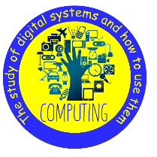 | Skills Showcase: Mars Rover 2 |  | What is a pixel? How is binary used to store and transfer image data, and why might a bitmap file be larger than a JPEG file?  How does the ‘fetch, decode, execute’ cycle work inside a computer, and why is it important to use safe usernames, passwords and responsible behaviour when using online 3D design communities? | Fetch-hyphen-execute A continuous 3 step process used by a computer CPU to process instruction.  Pixel The smallest controllable unit of a digital unit or display.
   | Painting and Mixed Media Portraits |  | How can words, materials, and composition be used creatively to make a portrait, drawing or self-portrait more interesting and meaningful?  How can artists experiments with different techniques and use art vocabulary to explain and compare their opinions of portraits and other artworks? | Print making An artistic process of creating artworks by transferring an image from a pre-prepared surface.
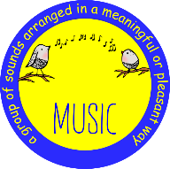 | Musical Theatre |  | What are the main features of musical theatre, and how can songs be identified as action songs or character songs?  How can performers use music, singing, dialogue and dancing together to tell the story of a journey effectively and perform smoothly as a group? | Transition A passage, section, or bridge that connects two musical ideas, themes, or sections, such as a verse to a chorus.  Downstage (the area of stage closest to the audience)  Upstage (area of the stage furthest from the audience)
 | Lacrosse and Athletics |  | What are the basic rules of lacrosse and how do players use a stick to pass, catch and shoot the ball?  Why are teamwork, communication and safe play important when playing a game of lacrosse? | Cradling Rapidly rotating the lacrosse stick in half turns while holding it near upright to keep the ball secure  Scooping Picking up a loose ground ball
 | Going to the Seaside |  | What items would you take to the seaside and why are they useful for a beach trip?  How can you use persuasive and extended sentences to create an advert or leaflet encouraging people to visit the seaside? | Guest: ¡Hola! Estoy muy bien, gracias. ¿Y tú? • Waiter/waitress:¿Qué querías? • Guest: Quería una tapa de ________ y __________, por favor. •

