Books we’re reading | 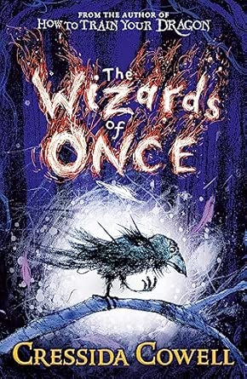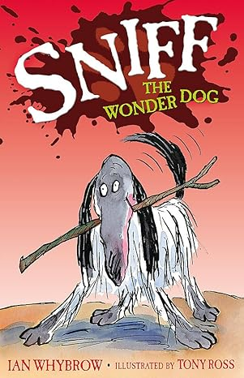
Music we’re listening to
Whole school spoken Grammar Focus | Correct use of was and were (Click here for help with this)

Special Dates  For Year Four | 1st – 14th June – Government Year 4 Multiplication Test  5th June – Spanish Day  Week beginning 15th June – Refugee Week  16th June – Trip to see the Halle Orchestra  17th June - Sycamore Class Assembly 9.15 am  19th June – Music Day  Week beginning 29th June – Health Week  2nd July – Celebration event for Primary Engineer project  7th July – Transition Day  9th July – PTA Colour run and fair (5.15pm)


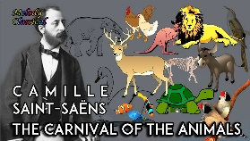


 | Unit of work |  | Discussion points/ how to help at home | Vocabulary
 |  | Money  Time  Angles  2D Shapes  Statistics  Position and direction | Helping with Money - Use real coins and notes Let children handle coins regularly. Ask: “What coins make 75p?” “Can you make £1.20 in different ways?” During shopping trips work out change from £1, £5 and £10. Compare prices and work out the best value. For example, “This cost £2.75 and I pay with £5. How much change should I get?”  Helping with Time – Year 4 children still need lots of practice reading analogue clocks. Focus on: o’clock, half past, quarter past/to, 5-minute intervals and minutes past/to. Throughout the day ask: “What time is it now?” “How long until dinner?” “If the football match starts at 2.15 and lasts an hour, when will it finish?” | An analogue clock is a circular face with a dial of numbers from 1 to 12.
 |  | 12 x Tables |       (Please contact class teachers if you need any login details)
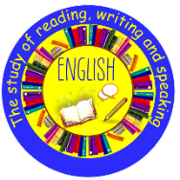 | The Lost Happy Endings by Carol Ann Duffy  Twisted Narrative – to narrate  Grammar focus –  Plural and possessive -s  Expanded noun phrases  Fronted adverbials  Use of paragraphs  Punctuation focus –  Use of commas when using fronted adverbials, after a reported clause and use of end punctuation within inverted commas |  | The book follows Jub, a magical six-fingered girl whose job is to collect the happy endings of fairy tales and release them into the night sky at bedtime. When an embittered witch steals her magical sack, stories go wrong, but Jub cleverly uses a golden pen to save the day.  What do you think the story will be about? What does a ‘happy ending’ mean? Why do people enjoy stories with a happy ending? Why are stories important to people? What is a simile? What is a metaphor? Draw a picture of the witch’s cave or the forest. | Simile - a way of describing something by comparing it to something else using 'like' or 'as'  - It was as green as a lizard.  - Metaphor - a fun trick with words that describes something by saying it is something else  - A wave of terror washed over him.  .
  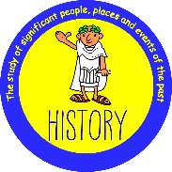 | Geography:  Why are Rainforests important to us? |  | Where in the world are tropical rainforests? What is the Amazon rainforest like? Who lives in the rainforest? How are rainforests changing? How is our local woodland used? | biome – a huge community of plants and animals that live together in a specific climate  vegetation – all the plants growing in a certain area  deforestation - the clearing, or cutting down, of forests.
 | Classification and changing habitats |  | In what ways can we group animals? In what ways can we group plants? What is a vertebrate? What are the 5 main vertebrate groups? How do humans have a positive and/or negative impact on the environment? | classification key a set of questions that helps you figure out exactly what something is by narrowing down its features, usually with "yes" or "no" answers, until you reach the correct group or name.  endangered - a plant or animal is "in danger" of disappearing forever
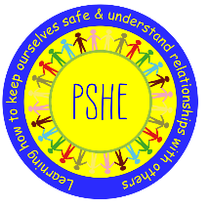 |  | Changing Me | Can I appreciate that I am a truly unique human being? Strategies to help cope with physical and emotional changes. Know who to ask for help if they are worried about change. What changes would I like to make next year and can describe how to go about these?  Check in with your child and see how they are feeling about the end of year and their thoughts about the new class they will be going into. What are their worries and what are they looking forward to. | Acceptance – agreeing to something or being okay with the way things are  Anxious – feeling worried, nervous, or afraid about something uncertain  Characteristics - the special qualities, personality traits, and actions that make them who they are
 |  | Relate  Engage  Transition
 | Why is the Bible so important for Christians today? |  | This unit gives pupils the opportunity to investigate how Jesus‚” teachings and actions reveal his hopes for a better world and what it means to live according to those values.  Opportunities for discussion, creativity, and empathy-building allow pupils to connect these values to their own lives and the world around them. They consider questions such as: What would Jesus say about the world today? What does it mean to live a life of service and love? | Values - the guiding principles and beliefs that help kids tell right from wrong and choose how to act.
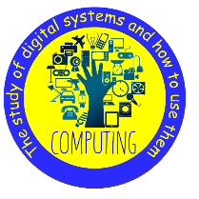 | Online Safety |  | What happens when I search online? How do companies encourage us to buy online? Fact, opinion or belief? What is a bot?  Talk to your children about keeping safe when using the internet. Explain some positive and negative distractions of using technology and small strategies for reducing the time spent on technology.
  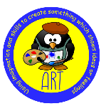 | Craft and Design: Fabric of Nature |  | What are the starting points in a design process? What techniques can we use to develop imagery?  How can we create a repeating pattern?  Look for patterns in the environment. Let children create their own repeating patterns. | Design – planning and making something with a clear purpose in mind  Techniques - special ways of doing something to get a good result
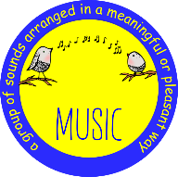 | Samba and Carnival sounds and instruments |  | Listen with attention to and recall sounds with increasing aural memory. Appreciate and understand a wide range of high-quality live and recorded music drawn from different traditions and from great composers and musicians.  What is Samba Music? Where does it come from? | Samba - a super fun, bouncy, and lively dance and music style that comes from Brazil  Carnival - a super fun, outdoor festival
 | Introduction to Athletics |  | Children will be able to develop speed, agility and quickness drills. Know how to sprint start. Throw a variety of small athletic pieces of equipment for distance. Understand the basics of jumping and landing. Understand that when running for distance they have to pace themselves in order to complete the distance set. Perform in a variety of events against each other.  Talk to your child about it is the taking part that is important and not always winning and why rules are set. | Endurance – the ability to keep doing something difficult for a long time without giving up, even when you start to feel tired  Precision - doing something exactly the same way every single time, or being super detailed and exact
 | Summertime |  | Ask your child about the weather and see if they can answer in Spanish  ¿Qué tiempo hace hoy? what’s the weather like today?  Hace sol – It’s sunny Hace calor – It’s hot Hace frío - It’s cold Hace viento – It’s windy  Está lloviendo – It’s raining Está nevando – it’s snowing Hay niebla – It’s foggy  Está nublado – It’s cloudy  . | el helado - the ice cream  Mi helado favorito es… - My favourite ice cream is…  Me gusta – I like  Me encanta – I love  No me gusta– I don’t like

