Books we’re reading | 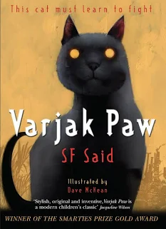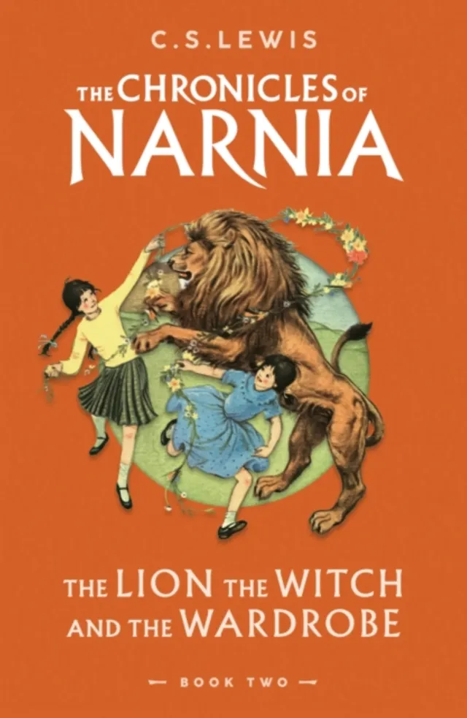
Music we’re listening to
Whole school spoken Grammar Focus | Correct use of was and were (Click here for help with this)

Special Dates  For Year Three | 5th June – Spanish Day  Week beginning 15th June – Refugee Week  16th June – Year 3 Trip to Eureka  19th June – Music Day  25th June – 3 Rowan class assembly  Week beginning 29th June – Health Week  7th July – Transition Day  9th July – PTA Colour run and fair (5.15pm)

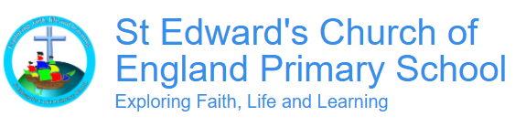
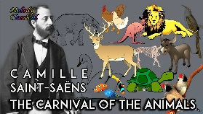


Subject | Unit of work |  | Discussion points/ how to help at home | Vocabulary
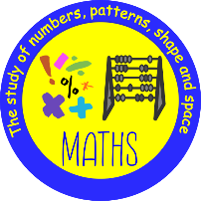 |  | Fractions  Money  Time | Fractions - Practical activities such as cutting up food into pieces and talking about halves, quarters, thirds etc. Looking at fractions of a quantity “let’s share these 12 grapes. What is half of 12?”  True or False:  Fractions must be made from equal parts.  Time - Looking at analogue clocks and identifying o’clock, half past, quarter past and quarter to. How many minutes until X?  Which hand on the clock shows the hours?  a) Minute hand  b) Hour hand  c) Second hand  Money - Use real coins and notes and allow children to handle these. Opportunities to use money in real life contexts (buying sweets from the shop).  A child has £2. She buys a drink for 75p and a snack for 60p.  How much money does she have left? | Whole  Part  Numerator  Denominator  O’clock  Half past  Quarter to  Quarter past  Pence (p)  Pound (£)  Cost  Price  Change  Total  Buy  Spend
 |  | X5 times tables |       (Please contact class teachers if you need any login details)
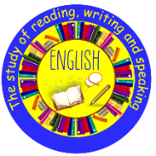 | English  Dear Earth by Isabel Otter  (Environment letter)
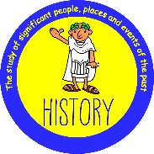 | History  What was important to ancient Egyptians? |  | BBC Bitesize have a wide range of informative videos about the Egyptians. Manchester Museum have a large collection of Egyptian artefacts.  Q: Why did Ancient Egyptians mummify bodies?  Answer: They believed the body needed to be preserved for the afterlife.  Q: Why was the River Nile important to Ancient Egyptians?  Answer: It provided water, food, farming land, and transport. | Civilisation – A large group of people with a common language, way of life and governance.  Ancient – From a very long time ago.  Artefact – An object made by a person that we can learn from.  Primary source – An object or record created at the time of an event or period of time.  Secondary source – An object or record created after an event or period of time.
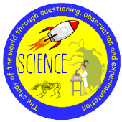 | Science  Making connections – does hand span affect grip strength? |  | Mini investigations at home for example; who is the strongest? Think about how they can carry out their investigation. How will they record their results? How can they make it fair?  Q: What is grip strength?  Answer: Grip strength is how strongly you can squeeze something with your hand.  Q: What should you keep the same to make the test fair?  Answer: Use the same equipment and test each person in the same way. | Variable - It is a part of an experiment that can change, be measured, or be kept the same.  Friction - A force that slows down moving objects when two surfaces rub together.
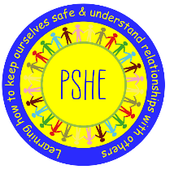 |  | Changing Me | Talk about growing and changing. Think about from birth to where they are now and how they have changed as they’ve grown. Look at photos of themselves and compare to them now. Look at younger siblings or cousins etc. How are they different to them?  Discussions about how their bodies will continue to change as they grow as they get closer to puberty. Discuss what puberty means and how their bodies will change and why. | Male  Female  Birth  Babies  Uterus  Womb  Puberty
 |  | Relate | Creating and maintaining healthy relationships. Who do we relate to? Friends, family and people within our community. Think about the importance of getting along with others and have healthy discussions about how we can be different or have different opinions or beliefs and still be respectful. | Relate – to get along with and understand other people.
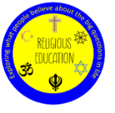 | How do festivals and family life show what matters to Jewish people?  What do Christians learn from the creation story? |  | BBC bitesize have some great videos and information on Judaism.  What do many Jewish people do to mark Shabbat?  What is the story of Pesach?  Jewish people rest on Shabbat because in the Torah they are told that as God rested on the seventh day of Creation, they should also do this. Jewish people have many festivals to help them remember key events in Jewish history. Rosh Hashanah celebrates Jewish New Year. Yom Kippur is a day to ask for forgiveness. Pesach is a meal to remember how Jewish people were freed from slavery in Egypt.  What do Christians believe about Creation?  How do Christians believe they should look after the world and our environment?  Genesis is the first book in the old testament and contains the story of creation. Christians believe the universe and everything in it was created in 7 days. Genesis also tells the story of Adam and Eve and how Eve was tempted to eat fruit from the tree of knowledge and committed sin against God. | Torah – The Jewish holy book.  Shema – A Jewish prayer.  Shabbat – A day of rest for Jewish people, the seventh day of the week.  Creation – The beginning of the World and everything in it.  Responsibility – A moral need to take care of something.  Genesis – The first book in the Old Testament.
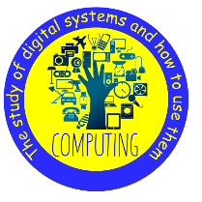
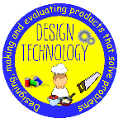  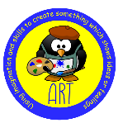 | Art  Craft and Design Ancient Egyptian Scrolls. |  | Q: What is a feature of Egyptian art?  Answer: People were always painted from the side.  Q: What is a symbol?  Answer: A pictorial way to represent something.  Q: Why is Ancient Egyptian art important?  Answer: It helps us learn about life in Ancient Egypt. | Ancient — Something from a very long time ago.  Material — What something is made from, like paper, wood, or fabric.  Civilisation — A group of people living together with their own way of life, rules, and culture.
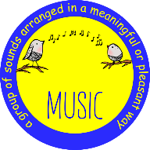 | Drumming  Rochdale Music Service
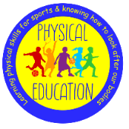 | Athletics |  | Q:What does speed mean in athletics?  Answer: Speed means how fast you can move from one place to another.  Q:What is agility?  Answer: Agility is the ability to move quickly and change direction with control and balance.  Q:What happens to your heart during exercise?  Answer: Your heart beats faster to pump more oxygen and energy around your body. | Power – Using strength and speed together to move forcefully, such as when jumping or throwing.  Stamina – The ability to keep exercising for a long time without getting too tired.  Technique – The correct way to perform a skill, such as running, jumping, or throwing.
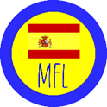 | Going on a picnic  Where I live |  | Hello: ¡Hola!  Good morning / Good evening: Buenos días / Buenas tardes  Please / Thank you: Por favor / Gracias  You’re welcome: De nada  Excuse me / Sorry: Perdón / Disculpa  Where do you live? Dónde vive?  I live in … Yo vivo en … | El picnic – the picnic  Un zumo – a juice  Aqua – water  Un bocadillo – a baguette  El campo - the field  El río – the river la Montaña – the montain  La arena – the sand  La playa – the beach  El desierto – the desert  El bosque – the forest  A través - Through Cruzando – Crossing Subiendo – climbing up Bajando - down  En – on  Para – to

