Books we’re reading | 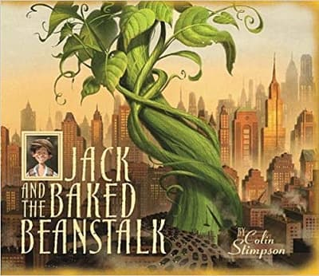
Music we’re listening to
Whole school spoken Grammar Focus | Correct use of was and were (Click here for help with this)

Special Dates  For Year 2 | 5th June – Spanish Day  Week beginning 15th June – Refugee Week  18th June – Parent Workshop (  19th June – Music Day  24th June - Parent/Carer Coffee Morning  Week beginning 29th June – Health Week  6th July - KS1 Parent Workshop with Miss Smith – 3.30pm  7th July – Transition Day  9th July – PTA Colour run and fair (5.15pm)


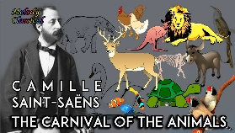


 | Unit of work |  | Discussion points/ how to help at home | Vocabulary
 |  | Fractions | Can you share 10 objects equally between 2 people? What fraction does each person get?  Can you find or draw a shape that is split into quarters? How do you know the parts are equal?  Can you explain what the numerator and denominator mean in the fraction$\frac{2}{4}$? | Denominator - the bottom number in a fraction – and how many it is shared into.  Numerator - the top number in a fraction. It tells you how many equal parts of a whole you are talking about.
 |  |  |   (Please contact class teachers if you need any login details)
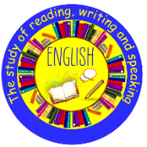 | Jack and the baked beanstalk |  | What type of writing is it and what is the purpose?  What is the grammar focus?  What is the punctuation focus?  What new words have you learned? | Exchanged - to give something and receive something else in return  Resist - to fight against, oppose, or try to stop something from happening
  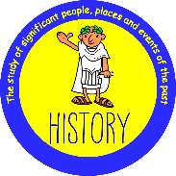 | Geography:  What is it like to live by the coast? |  | What seas and oceans can you find around the UK, and where are they on a map?  What physical and human features might you see at the coast?  How do people use the coast, and how can we record what we see there? | Coast - A piece of land along the sea or ocean.  Coastline - Where the sea meets the land.
 | Making Connections - Plant based materials |  | What do the words reduce, reuse and recycle mean, and why are they important?  Which materials are best for making an eco-friendly plant pot, and why?  What do seeds need to grow well, and how can we find out by testing and observing? | Recycle - To use energy so that a material can be used again.  Reduce - To not use something as much.  Reuse - To use something again.
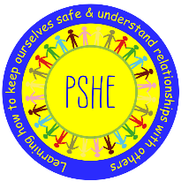 |  | Changing Me | What is a life cycle?  How have you changed since you were a baby?  How will you change over the next year / 5 years / 20 years? | Life cycle - the different, repeating stages a living thing goes through  Timeline - a visual tool used to show the order of events in chronological order
 |  | Relate  Engage  Transition
 | Who is Jewish and what do they believe? |  | What special words do Jewish people say in the Shema prayer, and why are these words important to them?  How does the story of Chanukah help Jewish people remember what God is like, and how do they celebrate this festival today?  Why do you think it is good for Jewish people to stop and remember, thank, or praise God—does that have anything to say to you too? | Synagogue – Jewish place of worship  Torah – Jewish holy text
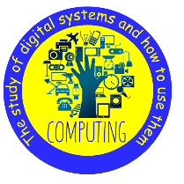 | Introduction to block coding |  | How can we break a game problem into smaller steps to help solve it?  What do different blocks in MakeCode do, and how do they fit together to make a program?  How can we put code blocks in the correct order and fix mistakes to make our game work? | Block - An instruction which can be dragged and dropped in to a sequence.  Code - A set of instructions written in programming language, to tell a computer what to do.
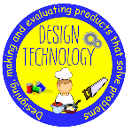  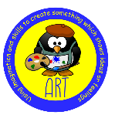 | Mechanisms:  Making a moving monster |  | How did you use levers and split pins to make your monster move?  What changes did you make after testing your monster or hearing feedback from others?  How does your finished monster match the design criteria and suit the audience it was made for? | Axle - A long, straight piece of material which connects to a rotating part (e.g. the wheels of a car).  Design criteria - A set of instructions for the project.
 | Sports Day Events |  | Can you practise getting dressed by yourself?  Try putting on your coat or jumper and zipping it up with a little help if needed. What parts can you do on your own?  Can you make a simple running course at home or in the garden?  Practise running, stopping, and changing direction quickly. How fast can you move around the obstacles safely?  Can you practise throwing and jumping skills?  Throw a small soft ball or rolled-up socks as far as you can using two hands or one hand. Then practise jumping and landing softly with bent knees. What helps you land safely? | Technique - the specific physical movement or "how-to" required to perform a sports skill  Control - the ability to effectively manage, restrain, and direct your body movements or equipment (like a ball) during a physical activity

