Our Author of the term: | 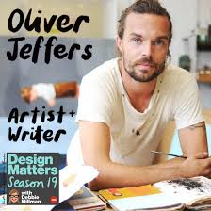
Music we’re listening to
Whole school spoken Grammar Focus | Correct use of was and were (Click here for help with this)

Special Dates  For Reception | 5th June – Spanish Day  8th June - R Elm Reading Café 2:45pm  Week beginning 15th June – Refugee Week  19th June – Music Day  22nd June - R Maple Reading Café 2:45pm  Week beginning 29th June – Health Week  7th July – Transition Day  9th July – PTA Colour run and fair (5.15pm)


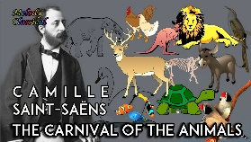


 | Unit of work |  | Discussion points/ how to help at home | Vocabulary
 |  | Numerical Patterns  Shape  Measure  Sorting  Time | Build the vocabulary into everyday routines to embed the language.  Play spot the difference/spot the odd one out. Ask the children why it is different?  Use different sized containers during bath time, use the language to discuss how much water is in the container.  Recognise shapes in the environment.  Share out food during meal times and discuss fair sharing. | Doubling, having, odd, even.  How many, same, different.  Half full, nearly empty, amount, equal, widest, narrowest, estimate, predict, compare.  Describe, odd one out, more than.  First, next, later, after, before, sequence.
 |  | Subitising to 10. | Looking at and recognising 10 in lots of different ways.  Sorting 10 objects and explaining how they have been sorted.
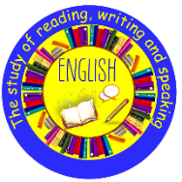 | Read aloud simple sentences and books that are consistent with their phonic knowledge, including some common exception words.  Write simple phrases and sentences that can be read by others. |  | Read children’s reading books daily.  Spot and read words in the environment.  Practice writing simple phrases/sentences such as ‘I can see a…’ ‘I like…’ | Segment  Blend  Finger space  Capital letter  Full stop
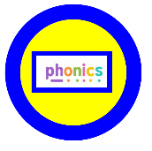 | 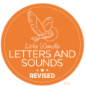  CCVC words  CCV words  Words ending is s/z/es  Longer words  Words ending in ing/ed/er/est |  | Practice phase 3 sounds and tricky words.  Read books daily – including school reading book.  Play reading games – hide words round the house for children to find and read. | Digraph  Trigraph  Tricky word  Segment
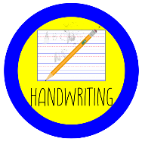 |   Capital letters |  | Play with playdough to strengthen hand muscles.  Use Little Wandle rhymes to practice letter formation.
    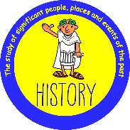 | Geography:  Know some similarities and differences between the natural world around them and contrasting environments, drawing on their experiences and what has been read in class. |  | Talk about different countries.  Look at maps together.  Share stories about different countries.  Talk about where you live and might go on holiday.
 |  | Changing Me | Can you name different parts of your body?  Talk about your best bits in Reception.  Talk to your child about moving to Year One. | Change  Memories  Healthy
 |  | Module 4 – Relate  Module 5 - Engage |  | Change  Memories  Healthy
 | What is special about our world? |  | Talk about how we can look after our world.  Discuss what is special about our world.  Talk about things they find interesting, puzzling or wonderful about the world. | Creation  Nature
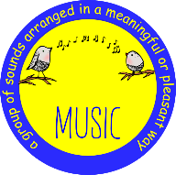 |   Big Band |  | Look at different musical instruments, what are they called?  Look at orchestra performance videos and discuss the sounds and instruments.  What type of music do they like listening to? | Audience  Orchestra  Performance
 |   Moving – Sports day events. |  | Discuss winning and losing.  Discuss fairness.  Discuss being part of a team. | Fair  Perseverance  Teamwork  Challenge

