

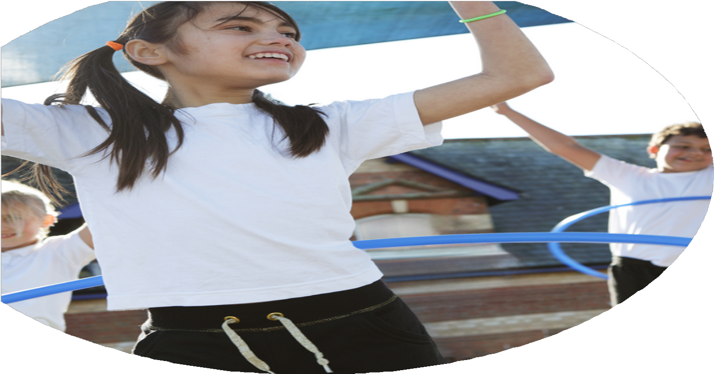





PE Funding

Evaluation Form

Commissioned by

Created by

Images courtesy of Youth Sport Trust

PE Funding Evaluation Form

It is intended that this template should be used as preparation for the completion of the statutory digital reporting tool being introduced this academic year. You can upload data (including swimming) from this template onto this platform once it becomes accessible.
Before you decide how you are going to use the funding for this academic year you should reflect and evaluate the impact of your use of the funding in 2023/24.
All spending of the funding must conform with the terms outlined in the Conditions of Grant document. The template is a working document that you can amend/update during the year.
Based on your evaluation of last year’s funding you should decide what you intend to do this academic year, how you will do it, and what impact you expect it to have.

It is important that the funding is used effectively and based on your school’s needs.
You must use the funding to make additional and sustainable improvements to the PE and sport in your school. You must develop and add to the PESSPA activities that your school already offers.

Summative digital reporting from June 2025 will continue to include swimming and water safety information therefore funding can be used to provide top-up lessons where necessary to ensure pupils meet national curriculum swimming requirements.

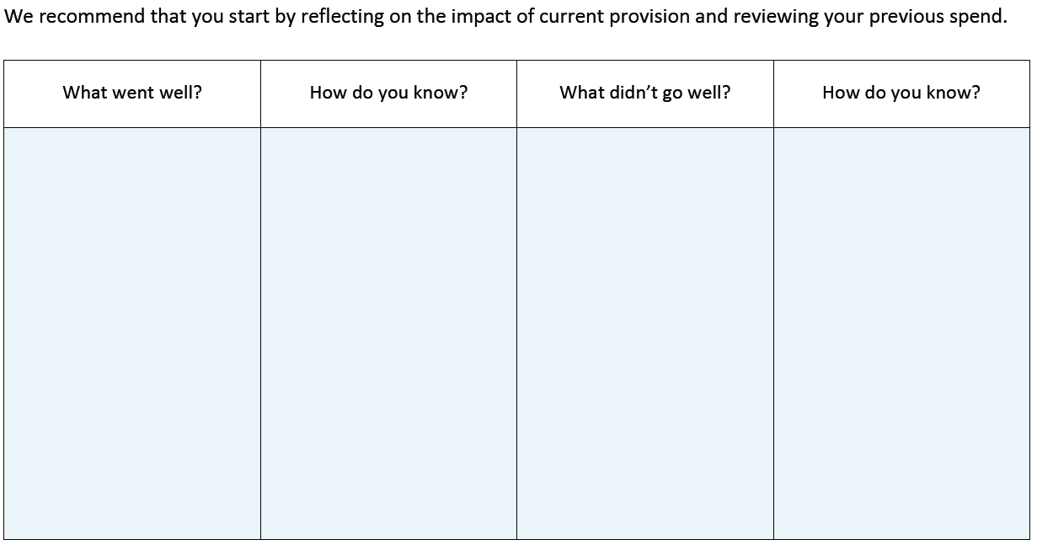
Offered a wide variety of lesser known sports.

Bought new equipment for: new sports, lunch/ break times. Listening to sports leaders.

Review the curriculum.

Competitions

Review the extra-curricular competitions with RUSC and Rochdale School Games to provide a variety of opportunities, at different competitive levels and engagement activities.

Provide more opportunities for PE co-ordinators to listen to pupils voice and for this to have an impact on the curriculum.

Pupil voice questionnaire to allow opportunities for children to have an input in after school and lunchtime activities. Also providing staff with knowledge about the children’s perspectives about their own sporting abilities and any out of school sporting activities that they do.

Speak to Edstart to encourage a wide variety of sports for after school to enable greater participation.

Create links with local clubs to provide a pathway for children.

Provide further training for TAs to support the children during lunchtime activities and to use within intervention groups. To also support within PE lessons.

Children to have half termly targets to improve physical ability.

For activities to be set up outside during break and lunchtimes to encourage competition, with leader boards displaying children’s names and scores.

To increase staff knowledge and confidence in PE working alongside Rochdale Football club (Primary stars) to provide training opportunities for staff-Team teach and Ed start.

Offer afterschool and lunch clubs related to upcoming sporting events and competitions.

To display and promote school sporting events on notice board/ website and twitter

Started off with lots of momentum but found getting equipment and setting up more of an issue. Same activities going out as it is easier. Speaking to staff.

Had cake sale due to pupil writing letter

Equipment hasn’t been going out at play/lunchtimes or has been left out.

One event cancelled and not put back on another we had to cancel due to staffing. Unable to attend many events due to staffing.

PE staff need more time to compile evidence and case study.
Lunchtime sporting activities available to the children

Need to use sport’s leaders more in school – children’s voice.

Need to look at storage of equipment for PE lessons and Playtime equipment.

Taking children out in school time – KS1/SEND events.

Achieved Gold Sports mark again but wanted to achieve Platinum.
Lots of children taking up afterschool activities, clubs full – used funding to buy equipment and sports coach for new club. Boom box for outside dance sessions.

Equipment bought ready for September to engage children to be more active. Had cake sale to raise more funds due to sports leaders writing letter and requesting to do a fund raising activity.

Curriculum change. Staff finding lessons more manageable to teach and children using more PE language. Need to make alterations to s plan so it works better for our school.

Lots of children taking part in competitions RUSC and RBSGP including more year groups. 3,4,5,6.
What are your plans for 2024/25?

Intent
How are you going to action and achieve these plans?

Implementation
- Continue with afterschool clubs to continue to offer activities for children that wouldn’t necessarily participate in sports.

- Have a specialized dance teacher come in for dance terms to provide dance lessons across the school, to ensure curriculum coverage. Encourage enjoyment of dance for all.

- Have sports leaders fully engaged and on task now they have had training.PE leads to meet regularly with children to discuss and evaluate sessions (supply cover needed)

- Train new sports leaders from year 4 to assist with KS1.

- Provide new equipment for playtime to increase sports participation. Buy equipment so that our children have the relevant resources so that children can be taught to a high standard.

- Have challenge boards around school(sport/fitness)

- Use funding to secure membership of local sports associations and bodies. This provides access to a wide range of competitions and festivals which broadens the experience of competitive sport that our pupils receive

- Identify training needs for staff and provide access to available professional development within the borough and beyond.

- For SEND children to have more access to competitive sporting events.

- PE and swimming sessions for children in Cherry Tree Room.
Discuss with Edstart a variety of clubs that we can offer the children based on the popularity of what worked this year.

Pupils receive high quality teaching in dance, improving pupil’s fitness, agility, coordination, communication and teamwork skills. Year 6 to have 2 half terms of terms of dance – curriculum and dancing to perform for an audience.

Use sports leaders to help set up, monitor and encourage activities at lunchtimes. To utilise children for in house and external competitions. Sport’s days, EYFS Swimming sessions, events/matches. Photos of sports leaders on PE boards.

Use RBSHP training with Julie Roberts.

PE coordinators and Edstart teacher to constantly replace equipment as and when needed – playground equipment to be placed in locked wooden boxes in KS2 playground. KS1 equipment to be in baskets to take out easily.

Boards to be bought and put up in playgrounds. Challenges changed half termly, challenge leaders to be named to encourage others to take on and practice challenge.

Ensure subscriptions to Rochdale Borough School’s Sports Partnership and RUSC partnership are paid on time.

Keep up to date with training offered by RBSGP and utilise as appropriate.

Children to access RBSGP – in daytime (supply cover needed to cover staff and transport costs.

Children to have a separate allotted slot in the hall, and appropriate activities set up.

What impact/intended impact/sustainability are you
expecting?
How will you know? What evidence do you have or
expect to have?
Letters to be sent out and Registers on Arbour. More children are engaged in physical activities during lunchtimes. More children enjoying physical activities.

Photos on PE boards, regular meetings, pupil voice. Resources being taken out and tidied away each day.

Children in the Cherry Tree room to be accessing PE sessions with activities appropriate to them. A PE curriculum to be developed between SENDCO and PE leads.

Pupil voice. Lesson observations, children able to perform simple dances in Reception with dances/moves becoming more complex as children progress through school.

More events attended. Children to feel comfortable to attend other schools and join in events. Photos, parental voice, pupil voice.

Lesson observations, Pupil voice, staff voice.

Arbour registers

Names on boards (leader boards) – run by sports leaders, Challenges changed half termly. Pupil voice.
More children to participate in a wider variety of extracurricular sporting activities – children trying different activities that they would not have otherwise tried – links with local sports clubs

Children to be trained by RBSGP, given confidence to lead sessions.
Sports leaders to be more involved and valued within the school.
Raising their profile within school. Leaders setting up equipment for lunchtime activities in KS1 and 2. Calmer playtimes, children showing their leadership and taking responsibility for activities

SEND children to have allocated slot in hall and Friday swimming sessions

Children to be confident in performing dance and progression throughout school – staff to feel more confident teaching dance in school. TA’s to feel confident to support children and join in with sessions.

More SEND events to be attended by children. – SEND children feeling valued.
More staff involved in taking children to events.

Staff training – improve staff confidence and CPD in teaching PE. Better quality PE sessions.

RBSGP and RUSC subscriptions – greater variety sport events entered, Leagues
Links made with schools in borough. Children in school mixing and learning about competition and sportsmanship.

Challenge boards – Children to take up challenges and work to beat last score, perseverance, be competitive.

What impact/sustainability have you seen?
What evidence do you have?

